Bellybra beats backache


Released on: December 17, 2007, 6:17 pm
Press Release Author: Fertile Mind
Industry: Apparel & Fashion
Press Release Summary: Sam Lee from www.6minutes.com.au – Interesting stuff for doctors today reports on a support garment helps pregnant women who get low back pain.
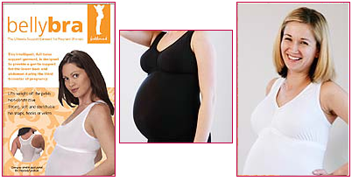
Press Release Body: Pregnant women who want to avoid lower back pain could do worse than get themselves a BellyBra, new research suggests. The BellyBra is a nylon-spandex garment that looks something like a camisole. It has a one-way stretch panel across the thoracolumbar region, designed to provide support and improve posture. It also contains a wide elastic band that sits below the abdomen, supporting the uterus and keeping weight off the pelvis. A study of 115 women in the third trimester showed that the BellyBra reduced pain scores more during sleeping, getting up and walking than did a control treatment with the more commonly used tubigrip. “The BellyBra and tubigrip were both associated with a reduction in the severity of pregnancy-related low back pain,” Melbourne University researchers write in the British Journal of Obstetrics and Gynaecology on Nov 12th. “The BellyBra was more effective than tubigrip, however, in alleviating the impact of pain on a number of physical activities that constitute daily life,” they note. The BellyBra is available from stockists all over Australia – for full listing refer to www.fertilemind.com.au.
Web Site: http://www.fertilemind.com.au
Contact Details: Fertile Mind Pty Ltd
Unit 12, 84 Old Pittwater Road
Brookvale NSW 2100
+61 2 9905 0199
www.fertilemind.com.au
sales@fertilemind.com.au

