Christian Reggae Rapper Tyrone Short challenges the criminal justice system for tougher laws to protect children


Released on: December 15, 2007, 12:10 pm
Press Release Author: Tyrone Short
Industry: Entertainment
Press Release Summary: A challenge to Congress, lawmakers, and the courts to impose the death penalty on sexual pedophiles.
Press Release Body:
Aurora, Co December, 2007
*Release Source: Tyrone Short
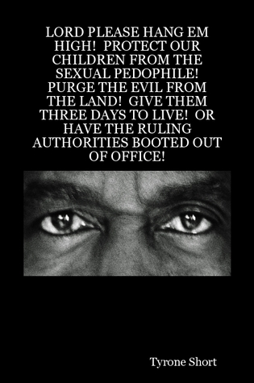
LORD PLEASE HANG EM HIGH! PROTECT OUR CHILDREN FROM THE SEXUAL PEDOPHILE! PURGE THE EVIL FROM THE LAND! GIVE THEM THREE DAYS TO LIVE! OR HAVE THE RULING AUTHORITIES BOOTED OUT OF OFFICE!
Of interest to editors and journalists covering: Law Enforcement, Legal Law, Politics, Death Penalty, Christianity, and Spirituality
Tyrone Short Announces Lord Please Hang em High! Protect our Children from the Sexual Pedophile! Purge the Evil from the Land! Give them Three Days to Live! Or Have the Ruling Authorities Booted out of Office! at Lulu.com.
Aurora, Co - November, 2007 / - Tyrone Short announces publication of Lord Please Hang em High! Protect our Children from the Sexual Pedophile! Purge the Evil from the Land! Give them Three Days to Live! Or Have the Ruling Authorities Booted out of Office in conjunction with Lulu (www.lulu.com), the world's fastest-growing provider of print-on-demand books.
There is a man out there in the shadows waiting for your family to turn out the lights. He is waiting for you to put your daughter to bed. He is the sexual pedophile and he wants to do things with her. When will the governing authorities administer the due penalty?
He took her when she was pure, and introduced her to sin. He took her when she was without blemish, and left a mark on her. At what point will the rendered sentences reflect the severity of the crime?
Tyrone Short designed Lord Please Hang em High! Protect our Children from the Sexual Pedophile! Purge the Evil from the Land! Give them Three Days to Live! Or Have the Ruling Authorities Booted out of Office! because of the saddening number of families that have lost their children to this plague of vicious attacks by these perverted men. This book is a passionate outreach to those who sit in office with the capability to make a difference for the future of our children.
Lord Please Hang em High! Protect our Children from the Sexual Pedophile! Purge the Evil from the Land! Give them Three Days to Live! Or Have the Ruling Authorities Booted out of Office! is available for purchase at www.lulu.com/PrinceTrog.
About the Author
Tyrone Short serves the body of Christ as Prince Trog, Colorado's One and Only Christian Reggae Rapper. He can be reached at the following:
E-mail: ChristianSilver@aol.com
Phone: 303-378-1346
Web Site: http://www.PrinceTrog.org
Contact Details: Tyrone Short
ChristianSilver@aol.com
303-378-1346

