Early Learning Centre release their latest toys to create a wonderful Christmas
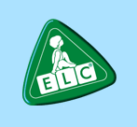

Released on: December 11, 2007, 6:58 am
Press Release Author: Early Learning Centre
Industry: Consumer Services
Press Release Summary: Christmas is always an exciting time for children, and with the addition of 500 new toys to the Early Learning Centre range, this year should be no exception
Press Release Body: Christmas is always an exciting time for children and this year at Early Learning Centre there are more than 2,000 wonderful toys to choose from, with over 500 new introductions this season.
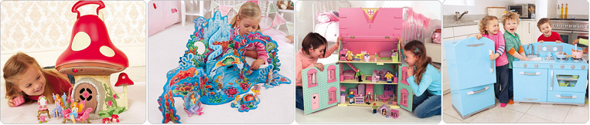
Christmas is about the magical realms of make believe, imagination and fairy tales. The Magical Fairy Toadstool (ages 3-8yrs), a pretty woodland home for fairies, is just one of the fantastic new Christmas toys available from ELC. Open the toadstool to reveal an upstairs and downstairs play area with two gorgeous fairies and their furniture. Children can just press the buttons to see lights and hear magical sounds.
Little mermaids can dream up under the sea adventures with the Mermaid Wonderworld (ages 3–8 yrs). This wonderful underwater kingdom has coral to swim around, shells to sit on, friendly sea creatures to talk to and a glowing palace. To add to this, there are glamorous sea princesses, King Neptune’s shell carriage and 4 beautiful mermaids who love to play under the waves. Rosebud Dolls House (3-8yrs) is a gorgeous three storey, painted doll’s house with fully opening front and attic. Children can arrange the room sets however they like and create their own family adventures and lose themselves in this tiny world.
Little cooks will fall in love with the Retro Kitchen (3-8yrs). A beautiful wooden kitchen in cool blue with an oven, two hob rings, dishwasher and sink. The roomy fridge freezer has plenty of space to store play food. With a kitchen as good as this children could run a top-starred play restaurant.

Evil alien Doc Tox is polluting the world with his smelly GLOBS (Gross Lumps Of Bad Smells). Only the brave Planet Protectors team (3-8yrs) with their clever vehicles can stop him. Children can choose Ice the arctic protector, Reef the sea protector, Kat the land protector, Eye the sky protector, Ridge the mountain protector or Ace the jungle protector. The Planet Protectors spaceship (3-8yrs) opens up into their HQ where Nuts the monkey is always on the look out for Doc Tox.
Brave knights will love the Castle of Courage (3–8 yrs) with 4 towers, turrets, battlements, flagpoles and working drawbridge. They can relive the old stories of knights in shining armour, wonderful wizards and epic conflicts with a range of accessory characters or come face to face with a Remote Control Dragon (3–8 yrs). He roars, walks and flaps his wings.
The magnificent wooden Pirate Galleon with cannons, crow’s nest, plank, helm, anchor and sails (3–8yrs) is a must-have for aspiring sailors. Who dares to sail into the cave on Skull Island (3-8yrs)? A fierce rocky outcrop with portcullis jaws, platform and rickety ladder across to the pirate landing stage.
Early learning Centre creates fantastic toys - toys that help develop vital skills, toys that help kids get off to the best possible start, and toys that are tremendous fun. A passion for learning through play and a commitment to quality make Early Learning Centre a wonderful experience for everyone this Christmas.
Web Site: http://www.elc.co.uk/
Contact Details: Press Enquiries – Early Learning Centre Press Office
ELC PR contact
Noella Dixon
PR Manager
Early Learning Centre
Daisy & Tom
Chelsea Stores
Burdett House
15-16 Buckingham Street
London
WC2N 6DU
020 7321 6428
http://www.elc.co.uk/

