Libellula Creations (LibellulaCreations.com) is announcing its Year End Sale

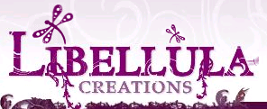
Released on: December 28, 2007, 12:49 pm
Press Release Author: Rhonda Smith/Partner
Industry: Apparel & Fashion
Press Release Summary: Don't miss the opportunity to have your child in the hottest brands from our prestigious collection at 15% to 40% off. Libellula Creations also announces the addition of Sugar Toes to their line of brand name shoes.
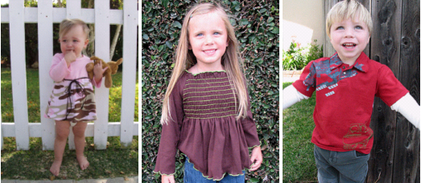
Press Release Body: The owners of Libellula Creations have taken great pains to bring their customers quality, upscale infant and toddler clothing that is edgy and will stand up to your childs lifestyle. You will find only the best brand names and quality clothing with manufacturers such as City Threads, Mad Sky, Trumpette, Splendid, Kea & Joby, Okkies and many more of the apparel industries best and brightest.
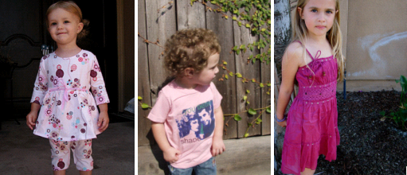
Libellula Creations is proud to offer a diverse line of apparel and accessories which include:
2 Red Hens | A Wish | B Squared
Baby Bella Maya | Baby Nay | Barn
Beary Basics | Belabumbum | Belle Baby Carriers
Boy?Girl | Bulrushes | China Doll Shoes
Circles Clothing | City Threads | Claesens
Cotton Caboodle | Da Lil Guys by Baby Nay | Darling Droolers
Devi Baby | Dogwood | Eberjey
Empress Arts | Esme | Fortune Tee
Granny Annies | Green T | Handmade by Mimi
J and Co | Kashwere | Kea and Joby
Kecci | Lil Punk | Love, Mom
Luna Luna Coppenhagen | Mad Sky | Mama Love
Mio Piccolo | Momzee | Nollie Covers
Nuckle Pacifier Chains | Okkies | Patricia Ann Designs
Pinc Premium TM | Red Decco | Samson and Martin
Sister Sam | Sonik | Splendid Littles
Sugar Toes | Trimester | Trumpette
Urban Smalls | Wonderboy
Libellula Creations is a privately held, California based on-line baby boutique. Their goal is to specialize in hip/urban infant, toddler, and maternity clothing as well as accessories. They personally hand pick all of their products and take pride in bringing them to their customers. Sizes range from 0 to 6x. Products include but are not limited to diaper bags, hooded towels, wash mits, children's footwear, baby blankets, stroller blankets, boys and girls clothing, tutu's, and various accessories.
This brings us to Libellula Creations philosophy. It is simply respect. Libellula's customers will find that respect goes hand and hand with customer service and their customers will definitely be treated like one of the family.
Libellula Creations motto is “Let your little Libellula fly in style.” This won't be difficult with all of the upscale, hip lines they have to offer.
Libellula Creations is also proud to announce that the sizes they offer now range from 0 to 6X.
Please visit us often!
Web Site: http://www.libellulacreations.com
Contact Details: Libellula Creations
16787 Beach Blvd., Suite 653
Huntington Beach, CA 92647
(714) 846-1081
(888) 545-3724

