Paul Rooney report a rise in winter sports travel insurance claims
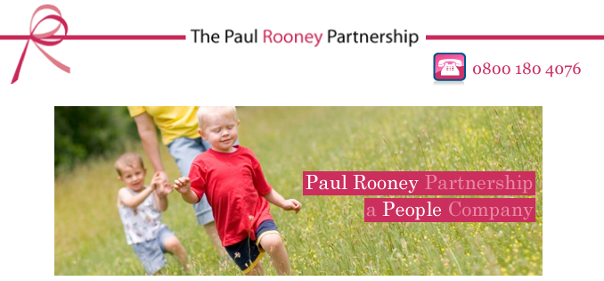

Released on: December 13, 2007, 2:30 am
Press Release Author: Paul Rooney Partnership
Industry: Law
Press Release Summary: The Paul Rooney Partnership, solicitors who specialise in personal injury and compensation claims, have reported that a third of all travel insurance claims are a result of winter sports accidents
Press Release Body: Snow capped mountains, alpine scenery, and lively après ski may be the holiday of dreams for many, but a recent study says that treatment for injuries that occur on ski slopes are responsible for a third of all travel insurance claims.
The Paul Rooney Partnership, solicitors who specialise in personal injury and compensation claims, have reported that there is an increase in holiday accident compensation over the winter season, due to the high likelihood of injury caused by skiing and snowboarding.
The differences in skiing and snowboarding give rise to distinct difference in the injuries picked up by participants of each sport. Skiers are most likely to receive injuries to the knees and thumbs; snowboarders tend to sustain wrist, forearm and ankle injuries. Injured snowboarders tend to fit a pattern of being young men or boys who are beginners and have had a minimal amount of instruction from a qualified instructor (many are 'self taught' or pick up the basics from a friend).
A spokesman from The Paul Rooney Partnership commented:
"Skiing is still growing in popularity with the Brits, so it's not surprising that we see a large increase in winter sports injury claims from people over the ski season. Compared to a beach holiday, the chances of injury are considerably higher, so it's especially important that skiers and snowboarders take out a good insurance policy that will cover them in the event of an accident on the slopes."
Typically, The Paul Rooney Partnership see a range of claims throughout the year including slips and trips claims, road traffic accident claims, criminal injury claims and claims for accidents at work, but during and after the winter season there is an annual spike in travel insurance claims due to the high number of winter sports accidents.
About Paul Rooney Partnership
The Paul Rooney Partnership are solicitors who specialise in personal injury and compensation claims. They have been practicing law for over 30 years and their lawyers offer the highest standards of service.
Renowned for being effective, efficient, friendly and down to earth, Partnership lawyers assigned client cases work hard on their client's behalf to deliver a resolution with the best possible result whatever the nature of the accident claim.
Paul Rooney have an excellent track record and a national reputation in the field of personal injury law and are confident that they can provide the service and support clients need with their claim for personal injury wherever they live in the UK.
Web Site: http://www.prp-online.co.uk/index.php
Contact Details: PR contact:
Steve Ireland
Stanley Court,
19 - 23 Stanlet Street,
Liverpool
L1 6AA
(44) (0)151 227 2851

