Sleepwellbaby announces new selection of sleep aids and sleep solutions for babies, children and adults.
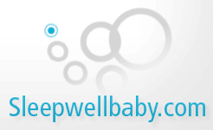

Released on: December 1, 2007, 1:02 am
Press Release Author: Valley Enterprises, LLC
Industry: Industrial
Press Release Summary: Sleepwellbaby (http://www.sleepwellbaby.com) is a unique three year old, web-based company has a variety of products to address the sleep problems of both adults and children. With these sound therapy products, sleep problems come to an end.
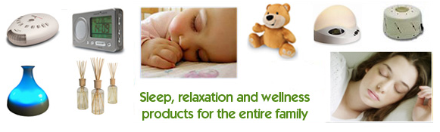
Press Release Body: Birmingham, AL, (express-press-release) December 3 – Sleepwellbaby offers solutions to the sleep problems of adults and children by offering a full variety of sleep, rest and relaxation products for adults and children. Sleep is as important to all human beings as food, water and air. Proper sleep helps the brain and body stay fit and also helps in fighting sickness and disease. Without proper sleep, the human body loses efficiency and also loses its ability to be productive. There is also a loss of concentration and focus. There are a variety of factors which affect the sleep patterns of adult and children such as noisy air conditioners, traffic, uncomfortable pillows, beds and most anything else. Additionally, everyone needs good and relaxed sleep to keep up with the hectic pace of the demands of everyday life. Sleepwellbaby has been featured in RedBook Magazine and on NBC's Today Show.
Sleepwellbaby has sleep, relaxation and wellness products for the entire family
Sleepwellbaby is a unique three year old, web-based company has a variety of products to address the sleep problems of both adults and children. With these sound therapy products, sleep problems come to an end. Sleepwellbaby offers sound machines that mask ambient noise for sleep, privacy, and concentration. White noise contains all frequencies of sound that humans can hear—similar to the way the color white contains all colors. Sound conditioners are used to soothe colicky babies, provide privacy in offices, and help second shift workers sleep during daylight hours. Some people also use them for help with meditation or yoga. Their popular white noise machines and sound conditioners are recommended by doctors for adults or children with sleep problems. The new Sound-Oasis Sound Therapy Machine includes unique sound card technology. Sleepwellbaby offers a variety of great products with many options for purchase.
Sleepwellbaby offers fine products from distributors and manufacturers such as: Marpac, Sound-Oasis, ObusForme, BioBrite, BeBeSounds, Basic Comfort, Pearlessence, Cloud B, Aromaland and others. Featured products include the SleepMate 980 White Noise Machine, BioBrite Sunrise Alarm Clock, Sound-Oasis Sound Conditioner, Sound Oasis Sleep Bear, Marsona DS-600A, ObusForme Sound Therapy Relaxation System, Sound-Oasis Deluxe and Travel Sound Conditioner and more. For those interested in Speech Privacy Systems and sound masking, white noise machines are also available for the office. For those who travel, sleep masks and eyeshades by Dream Essentials are perfect for the airplane and hotel.
Sleepwellbaby has an assortment of aromatherapy and air therapy products. Aromatherapy products such as fountain misters and diffusers help create a soothing and peaceful environment for the entire family. With the Lavender Lab, children are treated to a wonderfully soft lavender aroma that will help them float away into a peaceful slumber. The Twilight Turtle uses light therapy, and is the first and only plush constellation nightlight ever created. It gently transforms nurseries and bedrooms into a starry night sky that comforts and calms children and adults alike. Children will experience wonderful sleep without disturbance. For expectant parents, the Prenatal Heart Listener by BeBe Sounds is the perfect gift!
Sleepwellbaby offers many sleep related items and sleep aids which are inexpensive and affordable. Sleepwellbaby will help transform the home into a spa-like environment.
"I highly recommend them to friends with new babies." says G.E., Macon, GA. While, A.R., Atlanta, GA says "We can finally walk on our wooden floors without waking the baby!"
Shipping:
Within continental US, Sleepwellbaby offers free shipping and delivery for orders of $49.95 or more.
About Sleepwellbaby (http://www.sleepwellbaby.com)
Sleepwellbaby is the tradename of Valley Enterprises, LLC. Sleepwellbaby is committed to providing the best quality products that help both babies and adults sleep faster, better and longer. Sleepwellbaby is owned and operated by a psychologist and mother. Sleepwellbaby's mission to provide quality sleep items for the entire family.
Contact Us:
Sleep Well Baby
217 Country Club Park
PMB#403
Birmingham, AL 35213
Web Site: http://www.sleepwellbaby.com/
Contact Details: Sleep Well Baby
217 Country Club Park
PMB#403
Birmingham, AL 35213

