The Lord of the Rings nominated for 7 Whatsonstage People’s Choice awards
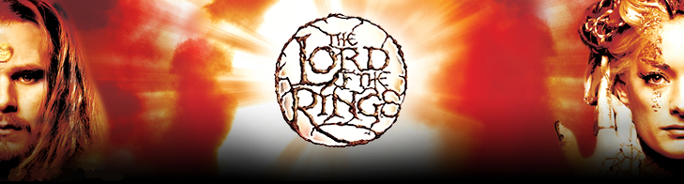

Released on: December 21, 2007, 7:09 am
Press Release Author: Peter Thompson
Industry: Entertainment
Press Release Summary: The Lord of the Rings stage show, at the Theatre Royal Drury Lane, has been nominated for 7 prestigious awards in the eighth annual Whatsonstage.com Theatregoers’ Choice Awards
Press Release Body: The 2007 nominations for the eighth annual Whatsonstage.com Theatregoers’ Choice Awards, recently announced at a star-studded event at Café de Paris in London’s West End, included 7 nominations for The Lord of the Rings, now playing at the Theatre Royal Drury Lane, London.
The Theatregoers’ Choice Awards is the only major theatre prize-giving decided by the public, who vote online. This year, a record 5,000 people took part in the nominations phase of the judging process, with many thousands more expected to vote for the eventual winners, which will be announced in February 2008.
The full nominations for The Lord of the Rings are:
- The Superbreak Best New Musical
- The See Tickets Best Actor in a Musical - James Loye
- Best Supporting Actress in a Musical - Laura Michelle Kelly
- Best Supporting Actor in a Musical - Michael Therriault
- Best Director - Matthew Warchus
- Best Set Designer - Rob Howell
- Best Choreographer - Peter Darling
The Lord of the Rings musical is an amazing live event, filled with jaw-dropping theatricality that transports theatregoers to Middle-earth as breathtaking special effects, thrilling music and dazzling performances fill the Theatre Royal Drury Lane.
The first major stage adaptation of J.R.R. Tolkien’s classic, The Lord of the Rings stage show has now been seen by over 300,000 people in London.
The reviews said “This show is a wonder. Go with an open heart, wide-open eyes, and prepare for enchantment” (The Times); “You’ve never seen spectacle like it” The Sun; “Theatrical magic –astonishing” (Sunday Times); “A hugely impressive production” (The Guardian).
Seventy years after J.R.R. Tolkien created Hobbits, all his amazing characters come vividly to life on stage including Frodo, Sam, Merry, Pippin and Bilbo, as well as Gandalf, Galadriel, Aragorn, Arwen, Legolas and Boromir.
Shelob the Spider, an army of Orcs and Saruman’s Black Riders (Ringwraiths) take over the Theatre Royal Drury Lane 8 times a week as The Fellowship undertake their adventure through Middle-earth to destroy The One Ring.
The production has book and lyrics by Shaun McKenna & Matthew Warchus and music by India’s renowned composer A.R. Rahman, Finland’s celebrated Värttinä & Christopher Nightingale. The show is directed by Matthew Warchus, with choreography by Peter Darling and set and costume design by Rob Howell. Lighting is by Paul Pyant, sound design by Simon Baker for Autograph, moving image direction by The Gray Circle, literary consultancy by Laurie Battle, special effects design by Gregory Meeh, illusions and magic effects by Paul Kieve, circus skills by Alex Frith and musical direction by Richard Brown.
India’s premier airline Jet Airways recently announced their sponsorship of The Lord of the Rings London original cast album, due for release in January 2008. The hit show The Lord of the Rings is now booking until September 2008, opened at the Theatre Royal Drury Lane in June 2007.
The Kevin Wallace Limited production of “The Lord of the Rings” is presented by Kevin Wallace and Saul Zaentz.
Web Site: http://www.lotr.com/
Contact Details: The Lord of the Rings PR Contact:
Peter Thompson
PTA
Flat 1
12 Bourchier Street
London
W1D 4HZ
(020) 7439 1210
info@ptassociates.co.uk

