Veteran B2B Marketer Lisa May Huby Launches Marketing 9-1-1 Marketing Consulting and Project Management for Small and Medium-Sized Businesses

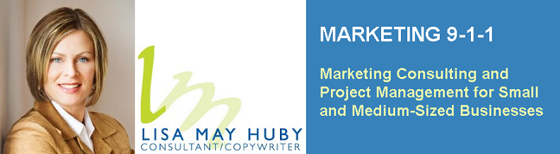

Released on: December 21, 2007, 7:00 am
Press Release Author: Lisa May Huby
Industry: Small Business
Press Release Summary: B2B Marketing Consultant and Copywriter Lisa May Huby announced the launch of Marketing 9-1-1, a new marketing consulting and project management program for small and mid-sized businesses.
Press Release Body: Barrie, Ontario December 21, 2007 - B2B Marketing Consultant and Copywriter Lisa May Huby announced the launch of Marketing 9-1-1, a new marketing consulting and project management program for small and mid-sized businesses.
Operating like a marketing agency, the idea behind Marketing 9-1-1 is affordable, one-stop shopping for busy business owners to have all their marketing needs met by means of a network of creative professionals including graphic and web designers, printers, photographers, advertising agencies and more. Every project is personally managed by Huby from start to finish, who acts as the client’s project manager.
“Since many business owners lack resources like time, money, and supplier connections for managing their marketing, I’ve developed a program that handles it all for them. They don’t need to worry about finding time to source suppliers or follow-up on projects, or continue working with outdated marketing materials. Essentially, Marketing 9-1-1 lets smaller businesses market themselves like larger corporations. We become their marketing team, with no long-term commitments or contracts, and we do it affordably,” Huby said of the program’s ideology.
Marketing 9-1-1 is a membership-based program, with two levels of service to choose from. The basic membership is ideal for businesses that want to keep their marketing materials current, and is priced at a budget-conscious $99.00 USD per month. Basic membership provides access to Huby’s network of creative professionals, and personal project management.
For businesses that require more in-depth marketing assistance and guidance, a Gold level of membership is available for an additional $149.00 USD monthly, which adds Huby as a marketing consultant to the package, for a total per month membership fee of $248.00 USD. Membership payments are handled electronically through Paypal, and major credit cards are accepted.
“It’s an excellent deal,” says Huby. “I even have a vendor in my network that offers website hosting, so it really can be a one-stop shopping experience for members.”
To launch the program, Huby is offering Gold memberships at 20% off to those that sign up by January 31, 2008.
Businesses looking for more information on the Marketing 9-1-1 program offered by Lisa May Huby should visit http://www.hubymarketing.com/Marketing_9-1-1.html, or send an e-mail to lisamay@marketing9-1-1.com. Alternately, she can be reached by telephone at (705) 812-2979.
Web Site: http://www.hubymarketing.com/Marketing_9-1-1.html
Contact Details: Lisa May Huby
336 Yonge St., Suite 338
Barrie, ON L4N 4C8
(705) 812-2979
lisamay@marketing9-1-1.com
info@hubymarketing.com

