Visitlondon.com launches Christmas in London campaign
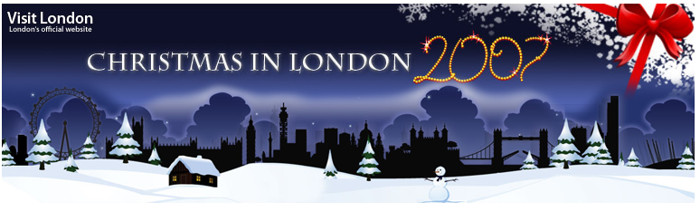

Released on: December 19, 2007, 3:02 am
Press Release Author: Visit London
Industry: Retail
Press Release Summary: Visitlondon.com, London's official website for visitors, is launching its Christmas in London campaign with a number of new competitions and games
Press Release Body: Visitlondon.com, London's official website for visitors, is launching its Christmas in London campaign with information on what's happening around London over the festive period as well as a number of new competitions and games.
The Santa’s Superbounce game challenges players to launch Santa as far as possible into the night sky by setting bounce power and speed using the mouse. The game is ideal for friends, families and work colleagues, as players can challenge others to beat their high score.
The visitlondon.com Christmas website offers a wealth of information for those looking to visit London over the festive season.
As one of the world's greatest cities for retail therapy, it's no surprise that thousands flock to the capital to do their Christmas shopping in London. Visitlondon.com offers a guide to the city’s best markets, fashion, luxury and department stores.
There’s also information on a wide range of special winter events in London, from pantos and festivals to Christmas markets and stunning light displays.
Hyde Park Winter Wonderland features London’s largest outdoor ice rink, an authentic German Christmas market, a toboggan slide and an incredible 50m giant observation wheel.
The Spitalfields Winter Festival runs until 21 December and offers an eclectic mix of concerts, tours and events in the vibrant heart of East London.
Each year ice rinks appear in some of the capital’s most iconic locations. This year visitors can get their skates on at venues as diverse as Hampton Court Palace, the Old Royal Naval College in Greenwich, the Tower of London, Kew Gardens, Somerset House and the Natural History Museum. The O2 is hosting an Ice Disco featuring music, 40 mirror balls, disco lights and a purpose-built bar.
Visitlondon.com also has suggestions for alternative ways to spend Christmas in London, whether visitors want a budget Christmas, a young Christmas, a family Christmas or even a gay Christmas in the capital.
For those wishing to make Christmas a more environmentally friendly experience the site includes advice on green gifts, reducing Christmas waste and presents that keep on giving.
There’s also a competition with fantastic prizes including a three-night break in London and tickets to top exhibitions and West End shows.
Ends
About Visit London
Visit London is the official visitor organisation for London. Its role is to promote London as the most exciting city on the planet, targeting domestic and overseas leisure and business visitors as well as Londoners. Visit London works in partnership with the Mayor, the London Development Agency and the tourism industry in London

Web Site: http://www.visitlondon.com/christmas/
Contact Details: Visit London Press Office contact:
Hannah Collingbourne
Visit London Press Office
2 More London Riverside
London
SE1 2RR
Tel: 020 7234 5843
Press office line: 020 7234 5710
Email: pressoffice@visitlondon.com

