Baby Clothes Clearance Sale
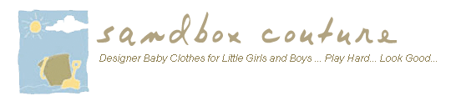

Released on: January 26, 2008, 6:19 pm
Press Release Author: Sam Brown/ Sandbox Couture
Industry: Retail
Press Release Summary: Sandbox Couture Offers 50-90% off on Designer Baby Clothes & Children's Clothing
Press Release Body: Rancho Santa Margarita – CA January 25, 2008 – Sandbox Couture, a popular online children's boutique retailer of baby clothes, baby gifts and designer children's clothing today announced its annual Baby Clothes Clearance Sale featuring savings from 50-90% off retail price.
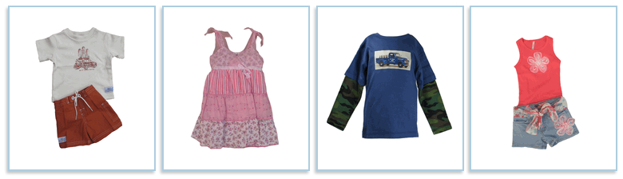
SandboxCouture.com must make room for new season additions and its expanded inventory, providing customers the opportunity to experience huge savings on designer children's clothes and baby clothes. Hundreds of items from top designers such as Flowers by Zoe, Sweet Potatoes, Big Fish, Stella Industries, Hanna Banana, Little Mass plus many others are available at reduced prices as part of the annual clearance sale.
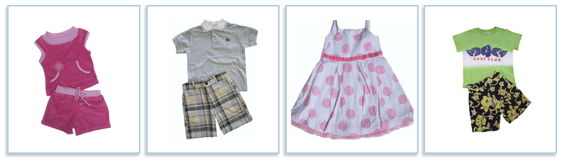
"Our Baby Clothes & Children's Clothes Clearance Sale offers amazing discounts on designer clothing for children and babies. Shoppers can find top designer brands at a fraction of their original price," stated Sam Brown, spokesperson for Sandbox Couture. "With the addition of this season's latest styles, much of the existing inventory is offered at incredible prices. We're already seeing a big spike in orders, so we encourage shoppers to waste no time, as sizes and styles are selling out fast," Brown concluded.
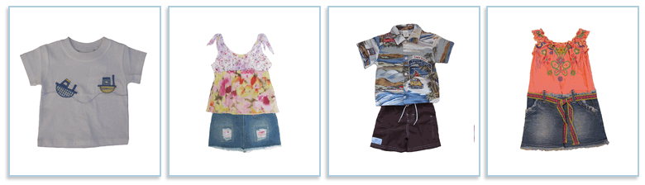
SandboxCouture has been selling baby clothes and designer children's clothes since 2005 and continually adds new clothing lines and unique baby gifts to its repertoire of high end fashions. Offering couture clothing, the online children's boutique provides hip moms and their fashionable little ones with the hottest trends and designer brands. For more information on the top fashions and must have brand names in baby clothes, children's clothes and baby gifts, please visit
http://www.sandboxcouture.com.
About Sandbox Couture
Sandbox Couture is an online children's boutique retailer, providing designer baby clothes, designer children's clothing and unique baby gifts. The company takes pride in hand selecting products from top designers, thereby ensuring quality and contemporary style. Sandbox Couture’s philanthropic contributions and socially conscious business practices are at the forefront of the company’s ideals and corporate culture. Founded in 2005, Sandbox Couture is privately held and headquartered in Rancho Santa Margarita, CA. For information about Sandbox Couture, please visit the company's web site at http://www.SandboxCouture.com
#
Web Site: http://www.sandboxcouture.com
Contact Details: Press Contact
Sam Brown
949-459-2505
pr@sandboxcouture.com

