British Airways Holidays provide extra help for holidaymakers booking a tropical beach break


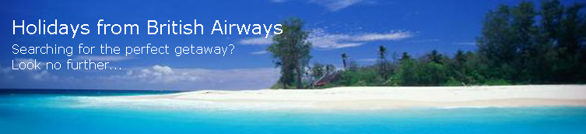

Released on: January 3, 2008, 7:53 am
Press Release Author: British Airways
Industry: Consumer Services
Press Release Summary: British Airways Holidays have made it easier for travellers looking to drift off to a far-away tropical paradise by adding the flexibility to book flights, hotels, car hire and transfers to their website
Press Release Body: Travellers looking for the perfect getaway can now book British Airways flights along with car hire, accommodation, transfers, travel insurance, and even site-seeing for many fantastic tropical locations, directly through the newly updated British Airways Holidays website.
The latest additions to the British Airways site are intended to make it easier to book a holiday, and to provide visitors with recommendations and the information they need, to make a properly informed decision on where and on which tropical island to stay. The site now also provides up to date flight information and travel news to help reduce the risk of suffering unexpected problems and allow travellers to get the most out of their holiday.
With 70 weekly British Airways flights available offering a choice of World Traveller, World Traveller Plus, Club World flat-beds and First Class on the majority of routes, holidaymakers have the flexibility to suit their budgets and individual requirements.
The Caribbean islands offer some of the world's top spots for a fantastic beach vacation and with online booking of hotels from 3 to 5 stars, and a range of special offers available, British Airways Holidays is able to provide a holiday in Barbados that has something for everyone. Destinations available include the Butterfly Beach which is a great value for money resort on the south coast in an ocean front setting with access to two white sand beaches and provides a friendly and relaxed atmosphere.
Antigua resort holidays continue to grow in popularity with new hotels like the Hermitage Bay and The Verandah opening. The family-friendly resort, The Verandah, offers 30 beachfront acres for parents to completely unwind as children can enjoy the Kidz Club or beach while the Hermitage Bay is perfect for couples.
Mauritius remains the favourite retreat for those looking to treat themselves to a spa holiday. With a good range of hotels all budgets can be catered for. Le Tropical is renowned for its family atmosphere whereas The Oberoi is perfect for couples wanting a romantic hideaway.
Until recently the Emirates remained an undiscovered jewel on the international tourist map. Now, more and more British Airways customers are taking Abu Dhabi holidays and discovering this unique and captivating destination, a ‘must see’ cosmopolitan experience which gives a real contrast to neighbouring Dubai.
In addition to being able to book flights, obtain destination recommendations, car hire, accommodation, transfers, travel insurance and tickets to many attractions, the updated British Airways Holidays site now also provides many exclusive offers. Through the British Airways Holidays site there are free night offers in many hotels with free kids' offers available. Free room upgrades and complimentary meals are also on offer in selected hotels.
Further more information on British Airways Holidays and the tropical beaches holidays on offer is available through the British Airways Holidays website.
About British Airways Holidays Ltd
British Airways Holidays Ltd. is a fully owned subsidiary of British Airways plc, which offers a selection of hand-picked hotel, car hire, transfers and sightseeing deals in most worldwide destinations. This includes many 'value for money' bonus offers such as free child places, free nights and car hire early booking. Working very closely with colleagues at British Airways, British Airways Holidays Ltd are constantly seeking to exceed customers' expectations, both in terms of the value for money and quality of the service provided.
Web Site: http://www.britishairways.com/travel/holidays/public/en_gb
Contact Details: British Airways Holidays Ltd PR contact:
Charlotte Lawrence
British Airways Holidays
Astral Towers
Betts Way
London Road
Crawley
RH10 9XA
01293 722513
http://www.britishairways.com/travel/holidays/public/en_gb

