Doctors Now Do It Though The Eyelid


Released on: January 3, 2008, 12:42 pm
Press Release Author: Michael Minch/ BiOCM Inc.
Industry: Healthcare
Press Release Summary: About a year ago no doctor would believe that it was possible, but today it is becoming a mainstream procedure. Inpatient & Outpatient Clinics such as Hospitals, Emergency Rooms, Nursing & Elderly Homes, General & Specialty Practitioners are joining Ophthalmologists and Optometrists with Unique Non-Invasive Test for Glaucoma.
Press Release Body: About a year ago no doctor would believe that it was possible, but today it is becoming a mainstream procedure. Inpatient & Outpatient Clinics such as Hospitals, Emergency Rooms, Nursing & Elderly Homes, General & Specialty Practitioners are joining Ophthalmologists and Optometrists with Unique Non-Invasive Test for Glaucoma.
BiCOM Inc. and its unique, FDA approved Tonometer Diaton now make it possible to safely and easily screen for Glaucoma through the EYELID with no contact with the Cornea using a small hand-held device and without the use of Anesthetic drops.
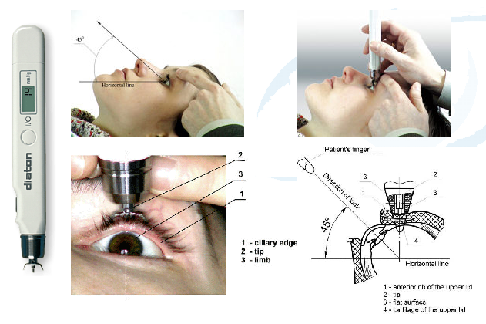
According to the American Academy of Ophthalmology, one in three Americans will suffer some form of age-related eye disease by age 65, one in two by age 80, but unfortunately few individuals are concerned with or even aware of their risk factors including their family history, ethnicity, undiagnosed diabetes and glaucoma.
By 2020, 43 million Americans will suffer significant vision loss or even blindness, the Academy predicts. Aside from protecting the eyes from accidents, early detection and treatment of vision-threatening problems is the Key to protecting one's sight and quality of life for later years.
Because eye disease in most cases advances without pain or symptoms, warning signs may go undiagnosed until someone can't read their morning paper, drive to the store, visit their doctor, or see the digits on their telephone. By having the eyes examined, especially for persons over the age of 40 will provide an early enough detection if glaucoma is indeed present.
Glaucoma is treatable, especially the acute form, and even if that is present, proper immediate treatment will restore normal vision. In chronic glaucoma, early detection is the only known cure at this time. Mr. Iospa, CEO of BiCOM Inc., has pointed out, "With the introduction of our unique tonometer Diaton, we're proud to challenge Glaucoma, a 'silent thief of sight', that carries an ever increasing threat of causing blindness as the aging population is growing in the U.S. and abroad."
Mr. Iospa added, "Medical doctors and Eye doctors must communicate. Adding this simple and safe procedure by using Diaton tonometer [Proactive Test for Glaucoma] would make the distance disappear, hopefully in time to save the patients eyesight…"
Eye doctors should also be ready to assist their colleagues in medicine with answers on Glaucoma and other eye related conditions, as well as being able to provide adequate care for the newly referred patients.
More information on the device, including clinical trials data can be found at http://www.TonometerDiaton.com or by calling BiCOM Inc. at the toll free number 1-877-diatons (877.342.8667).
Diaton tonometer is delivered complete with training Video/DVD describing full procedure step-by-step in addition to the Test/Training Eye™ which is included with each unit.
BiCOM Inc. also provides professional phone based support and training.
About BiCOM Inc.
BiCOM, with its 15 years of tradition and global clientele, has proven to be the enterprise of the highest level of professionalism, integrity and financial solvency. A unique team of engineers, medical, legal and business experts makes BiCOM Inc. the right place for global talent to find support and guidance.
BiCOM Inc. currently represents and supports Diaton tonometer in over 30 countries.
More about BiCOM at http://www.BiCOM-Ophthalmic.com
Web Site: http://www.TonometerDiaton.com
Contact Details: BiCOM Inc.
Michael Minch
“diaton-tonometry” revealed...
Toll free: 877.diatons(342.8667) ext. 705
Fax: 888.260.0606
Email: Michael[at]tonometerdiaton.com
Web: http://www.TonometerDiaton.com/

