Embassy Suites Hotels launches businessbalance.com to help business travelers maintain balance on the road


Released on: January 29, 2008, 3:14 am
Press Release Author: Embassy Suites Hotels
Industry: Consumer Services
Press Release Summary: Embassy Suites Hotels has launched their new online resource offering road warriors a ‘balanced’ perspective
Press Release Body: Embassy Suites Hotels, with 187 upscale, all-suite hotels in the U.S., Canada and Latin America, has announced the launch of Business Balance (businessbalance.com), a new initiative designed specifically to help business travelers stay on their “A Game” while traveling. Accredited sources on nutrition, exercise and sleep will offer business travelers guidance and tips to help maintain balance on the road. The site will be moderated by a “virtual editor,” a respected travel expert who will offer commentary on current business travel trends. BusinessBalance.com launches in January of 2008.
“This year, Embassy Suites wants to offer guests the ‘anti-new year’s resolution,’” said John Lee, Vice President, Brand Marketing and Communications, Embassy Suites Hotels. “There are lots of web sites that tell you what to do in order to be successful. We want guests to know that, while they may not be able to stick to their standard regimen while traveling on business, they can achieve the balance that works for them. Embassy Suites will provide business travelers with the tools they need to build confidence, strength and relaxation to help achieve peak business performance.”
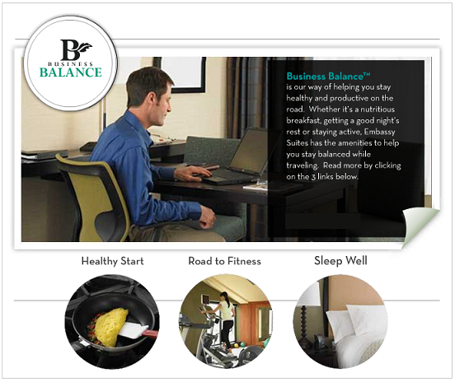
The BusinessBalance.com site is designed to give visitors an overall sense of ease – just what every business traveler needs to stay balanced and organized. It will be divided into two paths: “Strength on the Road” and “Serenity on the Road.” “Strength on the Road” will feature articles and tips on keeping a strong body, a strong mind, getting the proper nutrition, keeping a business traveler looking their best and maintaining family ties while on the road. “Serenity on the Road” will offer tips for business travelers to get better sleep, reduce stress on the road and pack efficiently.
Gary Chisholm, Business Travel Expert for About.com will serve as the “Virtual Editor” of BusinessBalance.com with his wife, Charlyn Chisholm, hotel expert for About.com. “I’ve studied the business travel industry for quite some time now and have seen trends come and go,” said Gary Chisholm. What I know is that in today’s 24/7, “gotta-have-it this-minute” environment, business travelers are thrown so much information so quickly that it’s easy to become overwhelmed and unbalanced. What business travelers need is to feel grounded and balanced in order to be productive.”
The web site will feature unique articles, Q&As and tip sheets from the virtual editors as well as experts on style, nutrition, fitness and sleep:
About Embassy Suites Hotels
Embassy Suites Hotels is part of the Hilton Family of Hotels and opened its first hotel in 1984. It was the first upscale all suite hotel brand to enter the industry and today has nearly 190 hotels.
Hilton Hotels is the leading global hospitality company, with nearly 2,800 hotels and 475,000 rooms in more than 80 countries, including 150,000 team members worldwide. The company owns, manages or franchises a hotel portfolio of some of the best known and highly regarded brands, including Hilton, Conrad, Coral by Hilton, Doubletree, Embassy Suites Hotels, Hampton Inn, Hampton Inn & Suites, Hilton Garden Inn, Hilton Grand Vacations, Homewood Suites by Hilton, Scandic and The Waldorf=Astoria Collection.
Web Site: http://www.embassysuites.com/
Contact Details: PR contact:
Dawn Ray
Senior manager
Embassy Suites Brand Communications
Embassy Suites Hotels
755 Crossover Lane
Memphis
TN
38117
US
(901) 374-5954
http://www.embassysuites.com/

