My Love Store Offers “Gifts With A Heart” For Valentine’s Day


Released on: January 14, 2008, 8:42 am
Press Release Author: Brian Estrin
Industry: Retail
Press Release Summary: Looking for a Valentine’s Day gift that really says “I Love You”? Then how about one that says “I Love My Schmoopie” or “I Love My Yaya”? Those are just two of the many hundreds of fun and original “I Love (Heart)” designs available from MyLoveStore.com, a top online retailer offering a variety of great gift products for Valentine’s Day including men’s and women’s apparel, mugs, teddy bears, magnets and a whole lot more.
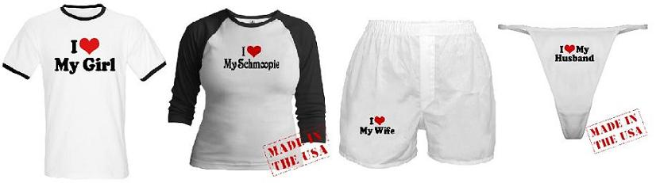
Press Release Body: LOS ANGELES, California (January 14, 2008) – Looking for a Valentine’s Day gift that really says “I Love You”? Then how about one that says “I Love My Schmoopie” or “I Love My Yaya”? Those are just two of the many hundreds of fun and original “I Love (Heart)” designs available from MyLoveStore.com, a top online retailer offering a variety of great gift products for Valentine’s Day including men’s and women’s apparel, mugs, teddy bears, magnets and a whole lot more.
Taking over 2 years to complete, MyLoveStore.com offers over 900 custom “I Love (Heart)” designs for everyone this Valentine’s Day and for almost any interest imaginable. “While there’s a lot of e-commerce ‘Love’ stores already out there, what really makes us stand apart is not only the vast array of designs available but their originality and uniqueness”, explains MyLoveStore.com founder Brian Estrin. “Instead of using the same cookie-cutter approach that many other stores have used, each design in MyLoveStore.com is an original creation that captures the subject matter in a simple yet iconic way that makes them truly special gifts.”
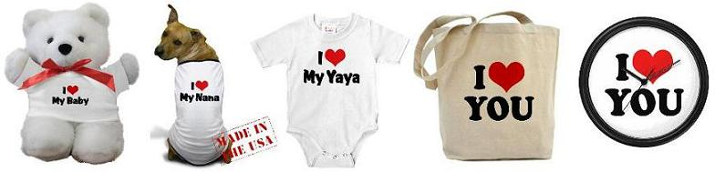
MyLoveStore.com offers all of their heart slogans on a variety of shirts for men, women and children, as well as on stickers, hats, bags, underwear, refrigerator magnets, buttons, and much more.
With Valentine’s Day fast approaching, online stores like MyLoveStore.com are becoming more and more the destination for people interested in purchasing a unique gift for a loved one at a reasonable price. The gifts come in a variety of sizes where applicable, and usually ship within 2 to 3 days of ordering with express shipping available for those in the market for a last minute gift. All products sold also come with a no-hassle, 30 day money back guarantee.
For more information on the website or to browse the site’s extensive catalog of gifts, visit www.MyLoveStore.com
Web Site: http://www.mylovestore.com
Contact Details: 18925 Sherman Way #28
Reseda, CA 91335
contact@mylovestore.com

