NFL Jerseys and Super Bowl XLII Merchandise at SidelineApparel.com
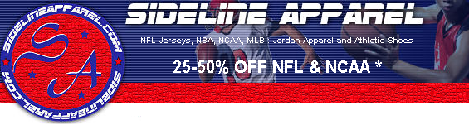

Released on: January 30, 2008, 4:04 pm
Press Release Author: Sbrown/SidelineApparel.com
Industry: Retail
Press Release Summary: Super Bowl XLII Locker Room Caps & Tees available on sale
Press Release Body: (Marshall, TX) January 30, 2008 – www.SidelineApparel.com, a leading retailer of NFL jerseys, NBA jerseys and sports apparel, today announced the site will be adding licensed NFL Super Bowl XLII sports merchandise to their inventory as the season comes to a close.
In addition to Super Bowl XLII merchandise such as Locker Room Caps & Tees, fans can show support for the last few weeks of football season with official NFL Jerseys and sports apparel. Shoppers can find a wide selection of New England Patriots NFL Jerseys, Green Bay Packers NFL Jerseys, San Diego Chargers, Dallas Cowboys, Indianapolis Colts and all the other NFL team jerseys. Sideline Apparel has been selling licensed NFL & NBA merchandise for nearly 20 years and extends its customer driven values by offering the lowest possible prices with an unbeatable selection of authentic NFL jerseys and licensed sports apparel and merchandise. With the 42nd NFL Super Bowl less than two weeks away, SidelineApparel.com has a full inventory of NFL jerseys and sports apparel at affordable prices.
"It's not too late to gear up for Super Bowl XLII," said Nathan Dean, spokesperson for SidelineApaprel.com. We offer customers 25-50% savings on NFL jerseys and sport merchandise plus fans can benefit from our unique "Any Size - Same Price" policy," Dean stated.
Sideline Apparel provides licensed merchandise featuring top players from NFL, NBA, MLB and NCAA teams. Offering a complete line of replica jerseys, throwback jerseys and authentic NFL Jerseys and NBA jerseys, SidelineApparel.com strives to bring spectator spirit to new levels. Fans can also find hats, beanies, pullover sweatshirts, flannel pajamas plus many other sports apparel items for fans of all ages and sizes. For more information on SidelineApparel.com or to start saving on NFL jerseys and sports apparel, please visit http://www.SidelineApparel.com.
About Sideline Apparel
Sideline Apparel was established in 1989 as a retail location located inside of a shopping mall. In 2003, the company began selling sports apparel and pro sports jerseys nationwide with the launch of SidelineApparel.com. Providing the best selection of NFL jerseys, MLB Jerseys, NBA Jerseys and NCAA jerseys and apparel, SidelineApparel.com ensures quality and affordability. Privately held, the company is headquartered in Marshall, Texas. For more information, please visit www.SidelineApparel.com.
Web Site: http://www.sidelineapparel.com
Contact Details: Press Contact
Nathan Dean
Public Relations
903-935-7365

