New Film Company In New York Scores Their First Big Project

Released on: January 8, 2008, 7:29 pm
Press Release Author: Brandon Kumm
Industry: Entertainment

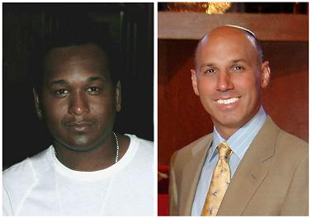
Press Release Summary: Bright Waters, New York - (Jan 1st, 2008) Successful Business and Real Estate entrepreneurs Byron McCray & Roy Greif have announced today that they will partner up and create a multi million dollar budget to develop a new film company McCray & Greif Films.
Press Release Body: McCray & Greif will Executive Produce their first project as partners "Full Order of Protection, Domestic Violence Files." This pilot series is based on an unreleased book by John Michael Leventhal, who is the first Judge to oversee a Felony Domestic Violence Court in the United States. "FOP" will bring Domestic Violence awareness to society by portraying real life situations to the screen (protecting the victim’s identity) and giving prevention tips. “These real life stories had me on my toes, I can’t believe these situations are in fact true and people have to go through these acts of violence”, Executive Producer, McCray.
"FOP" will be shot in McCray & Greif's new film studio in Bright Waters, Long Island. The set is currently being designed and filming will start around Jan 19th.
McCray & Greif Films ventures to become one of the most successful independent film companies to produce innovative, popular and profitable entertainment. In addition to the there production they want to bring you home entertainment, television, music, and theater on an international level.
Web Site: http://www.karmaauditions.com
Contact Details: 1308 Richland Blvd
Bayshore, New York 11706
516-983-5629
brm78@tmail.com

