New organic fast food restaurant concept launching by April 1, 2008
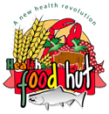

Released on: January 23, 2008, 2:01 pm
Press Release Author: James M Sleighter / President
Industry: Food & Beverage
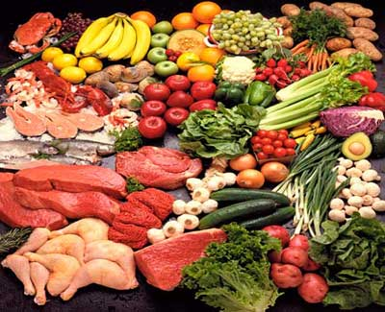
Press Release Summary: Healthy, Natural and Organic Foods are in demand by the consumer, but current offerings are sorely lacking and quite limited. We are bringing healthy to the vernacular of the fast food industry. Organic food and local produce is in demand. Our restaurant will not only be organic but green. Planet friendly design including hydroponics on the roof. All takeout containers, trays, and tableware will be made of the latest degradable technology. Unlike other plastic, once degradation is complete, all that remains is carbon dioxide, water and biomass, all of which are part of the normal bio-cycle.
Press Release Body: The concern and demand for safe food has never been higher. Americans are just plain tired about having to worry about the latest contamination, E Coli or tampering scandal of the week, and they have the right to be. This year has been especially troubling, with all of the outbreaks, contamination, cloning & genetic altering stories in the media. Where will it all end? Our menu will feature the nutritional value and the origin of all of our foods and ingredients. Say goodbye to the days of mystery meats, poultry and/or fish. Consumers will know what they are being served and from where it arrived, period. And it will be food grown, raised and farmed by and for Americans.... We have done extensive research on the food industry for the last several years and we believe we have found the solution to the lack of health-conscious fast-food locations throughout the U.S.
The solution is Health Food Hut, the countries first Organic and All-Natural Fast Food Restaurant featuring all- wild Alaskan seafood, organic beef and chicken, organic salads and wraps, and much, much more. By eliminating the distributor, and buying direct, we will be able to be price our meals within reach of the casual fast-food buyer. The organic industry is growing fast, and we are ready to do our part and strike while the iron is hot... Health Food Hut will be unique in the industry. A fast-food establishment that offers healthy alternatives via in-store, carryout and drive-through purchases, comprehensive retail meat and produce offerings and even home delivery.
We also will be launching Save the Planet Organics. Fresh cut produce, salads, and wraps in degradable green containers. This will enable schools, restaurants, business, convienience stores,and hospitals to introduce organic food to their menu or offerings. Quickgreens which will be a healthy green drink with no mess. For those on the go.
We have teamed up with industry giants to make our concept a complete success.Visit our website for more info.
Web Site: http://healthfoodhut.com
Contact Details: James M Sleighter
Health Food Hut Inc
1024 North Atlantic Ave
Daytona Beach, Florida 32117
http://www.healthfoodhut.com
imasters@tampabay.rr.com
(352) 201-2536
Your health is your biggest asset......

