SAGA Named Most Anticipated Upcoming Collectable Game
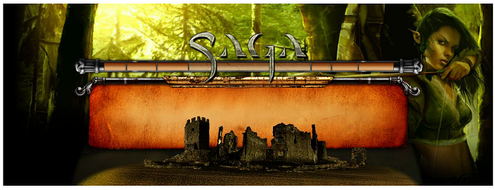

Released on: January 10, 2008, 2:34 pm
Press Release Author: Silverlode Interactive
Industry: Computers
Press Release Summary: SAGA, the first collectable online real time strategy war-game is ranked #1 by player poll.
Press Release Body: The collectable game industry is buzzing with news about SAGA’s entry into the retail space. SAGA stands alone as the first and only collectable online realtime strategy game. SAGA’s unique game mechanics allow players to use their collectable online miniatures for questing and player-versus-player combat. Unlike all other online collectable games which are turn based, the SAGA game pieces come to life on the battlefield.
A recent poll on tcgplayer.com, a top collectable game review site, boasting 248,553 unique monthly visitors, ranked SAGA as the #1 anticipated collectable game, beating out the upcoming “Magic: the Gathering” and “World of WarCraft” CCG expansions. “We are ecstatic at the news but we do have an unfair advantage, being an online realtime collectable miniature game in a field of collectable card games. We are currently hard at work using feedback from our closed beta test to further improve the game,” said Slava Zatuchny, Marketing Director for Silverlode Interactive.
Silverlode Interactive is currently holding a number of promotions offering players priority access to the SAGA closed Beta. Many hobby stores across America and Canada have received postcards with priority Beta codes usable at www.playsaga.com/signup_beta.php. In addition, select websites will be offering a limited number of Beta spots, a complete list of which will be available at www.playsaga.com next week.
Silverlode Interactive is currently in talks with major distributors to hobby and comic book stores as well as large retail chains to sell SAGA booster packs and starter decks. The SAGA booster pack will contain a code redeemable for 10 collectable miniatures online. The SAGA starter deck will contain a full registered version of the game as well as three booster packs. A full list of distributors will be posted on www.playsaga.com this month. Interested store owners may contact their sales representative for more information.
About SAGA – SAGA is a persistent world RTS in an epic fantasy setting. Players collect troops, build armies, conquer new lands and build up kingdoms, complete with resource collection, city building and peasant management. SAGA’s features include massive armies, multiplayer questing, guild wars, espionage, and an auction house for trading troops and spells.
SAGA has no subscription fees. Players pay as little or as much as they decide, by purchasing ‘booster packs’ of random troops and spells, which are traded and customized to create the strategic army of choice for each player. Visit www.playsaga.com
Web Site: http://www.playsaga.com/
Contact Details: Slava Zatuchny
Silverlode Interactive
Tel. (617) 905-8482
Email: szatuchny@playsaga.com
URL: www.playsaga.com

