The real life story of a boy who grew up with Undiagnosed Attention Deficit Disorder


Released on: January 26, 2008, 5:30 am
Press Release Author: Adderworld.com
Industry: Media
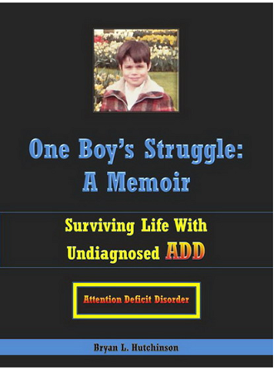
Press Release Summary: ‘One Boy’s Struggle: A Memoir - Surviving Life with Undiagnosed ADD’
Bryan L. Hutchinson bravely reveals the story of his life, the tragic details of his struggles and futile efforts to be a better student and son. Bryan eventually was diagnosed with ADD at the age of 37. Diagnosis and understanding gave Bryan the inspiration to write his life’s story. It is believed that Bryan’s Memoir is the first such Memoir about a person growing up with undiagnosed ADD.
Press Release Body: “Diagnosis has been the most liberating experience of my life.” Bryan says, obviously relieved and with a mixed smile of hope and wonder. “I have been in Therapy for over ten years and have been misdiagnosed for longer than that. I have always known I am different, but I just didn’t know why or what I could do about it—now I do and life has started anew for me.”
Bryan has written his story to help others understand the truth of ADD, how it affects a person living with it day in and day out. He wants to raise awareness of what Attention Deficit Disorder is and also articulate the positive sides of the disorder. He believes the negative stigma surrounding ADD comes from misinformation and the deep rooted belief that ADD ADHD is an excuse for laziness.
“Too many people are in denial and this denial hurts not only the people with ADD or ADHD, but it also hurts everyone who comes in contact with an undiagnosed person with ADD ADHD” Bryan’s words are said with a genuine intensity and a hint of dissatisfaction. “Society suffers from the denial of ADD and ADHD, Relationships suffer, the schools suffer and the economy suffers. When correctly diagnosed with ADD or ADHD a person can move on and improve, but while living undiagnosed the ability to improve is far less likely and therefore the economy suffers, because the workforce suffers. People with diagnosed ADD can work much better and accomplish more than those with undiagnosed ADD and still suffering.”
Although millions are already diagnosed with ADD or ADHD, it is believed that millions of people still go undiagnosed. Some adults are still at risk of remaining undiagnosed because of misunderstandings and misinformation and fear of the ADD ADHD negative stigma, which is still prevalent today.
Bryan’s book is his attempt to help others understand that having ADD or ADHD does not have to be devastating or destructive. “There is hope, I have become successful because I have educated myself about my disorder and I have used the positive traits that come with the condition of ADD to improve myself and others can do this too. My book gives examples of how I have improved.”
Jennifer Williams, a mother of an ADHD child and an early childhood educator says “Bryan’s book has helped me understand my child better from a personal perspective and has given me fresh and positive insider information which has helped my family a great deal. I already understood the medical side, but the human, personal side is also very important, if not more important. His book is going to be a blessing for millions of people around the world.”
According to the synopsis, Bryan strived to do well in school and please his parents, but he couldn’t, no matter how hard he tried. He was always daydreaming and distracted and had trouble accomplishing his schoolwork, never understanding why he wasn’t like other students. His teachers and peers ridiculed him for his inattentiveness at school, while his father punished him for failing grades and presumed laziness at home.
Bryan’s book is available online at:
http://www.buybooksontheweb.com/product.aspx?ISBN=0-7414-4440-2
“One Boy’s Struggle: A Memoir – Surviving Life with Undiagnosed ADD” is also available at most other major online book sellers.
For more information about Bryan, you can also visit his blog www.adderworld.com
Web Site: http://www.adderworld.com
Contact Details: Bryan.hutchinson@adderworld.com

