Titanium Ring Stops A Bullet


Released on: January 16, 2008, 1:13 pm
Press Release Author: Ron Yates/Titanium-Jewelry.com
Industry: Apparel & Fashion
Press Release Summary: Mens Titanium Ring Saves Man's Finger
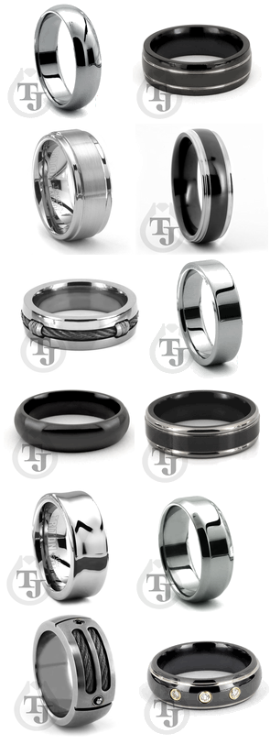
Press Release Body: (Modesto, CA) January 17, 2008 – Titanium-Jewelry.com, a leading online retailer of titanium rings and tungsten rings, including men's wedding bands and modern contemporary metals from top designers, today announced the incredible story of a titanium ring stopping a bullet from striking the finger of a recent customer.
David Bradshaw of Baytown, Texas purchased a titanium ring after researching the quality and durability of titanium rings. While conducting maintenance on his 40 caliber handgun, the gun misfired, releasing a bullet from the chamber and causing it to graze his hand. Bradshaw was wearing the titanium ring he had purchased from Titanium-Jewelry.com at the time of the accident. His titanium ring ended up saving the loss of his ring finger and numerous surgeries. The bullet first hit Bradshaw's titanium ring, deflecting it and preventing injury to his ring finger.
Titanium has long been recognized as a practically unbreakable metal. Its tensile strength is a quality that makes it ideal for many uses, including men's wedding bands and modern jewelry designs. Bradshaw selected a titanium ring after learning about the durability and of the metal, as his occupation is one in which he handles heavy equipment. Titanium-jewelry.com has been at the forefront of contemporary jewelry for several years, providing visitors the very best in titanium jewelry and tungsten jewelry designs.
"It's no surprise that titanium is strong enough to stop a bullet, but I never dreamed that one of our titanium rings would help save a customer's finger from injury," stated Ron Yates, founder of Titanium-Jewelry.com and owner of Yates & Co Jewelers in Modesto, CA. "Our rings are guaranteed forever and virtually indestructible, we even offer a lifetime guarantee with our Ring for Life program," Yates concluded.
Titanium-Jewelry.com offers a hundreds of designs, including tungsten rings, titanium wedding rings, black titanium rings, traditional titanium rings for men and women and men's wedding bands. For more information on titanium rings visit http://www.titanium-jewelry.com or to listen to the podcast of this amazing story, please visit http://www.titanium-jewelry.com/bullet-podcast.html.
About Titanium-Jewelry.com
Titanium-Jewelry.com provides a wide selection of tungsten rings, titanium rings and black titanium rings uniquely styled for men and women. Experts in modern men's wedding bands, including titanium wedding rings and modern metals jewelry, Titanium-Jewelry.com leads the industry in contemporary jewelry fashions. For more information, please visit www.Titanium-Jewelry.com.
#
Web Site: http://www.titanium-jewelry.com
Contact Details: Press Contact
Ron Yates
Founder
Phone: 800-370-2646
Email: ron@titanium-jewelry.com

