Titanium-Jewelry.com Launches Video Webcasts


Released on: January 14, 2008, 8:16 pm
Press Release Author: Ron Yates/Titanium-Jewelry.com
Industry: Retail
Press Release Summary: Videos Demonstrate the Durability SAW Test on Titanium Rings
Press Release Body: tungsten rings, titanium rings, black titanium rings, mens wedding bands
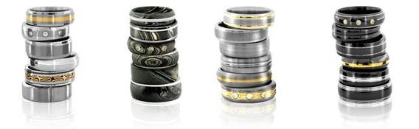
(Modesto, CA) January 10, 2008 – Titanium-Jewelry.com, a leading online retailer of tungsten rings and titanium rings, including titanium wedding rings, black titanium rings for men and women, today announced the launch of new video and podcasts now available for customers shopping for titanium and tungsten rings. The video webcasts show viewers amazing demonstrations on the durability of different types of men's wedding bands. Visitors can view these incredible videos and gain valuable information on the differences between contemporary metals such as gold, titanium, platinum and tungsten rings.
Titanium-jewelry.com has been at the forefront of contemporary jewelry for several years, providing shoppers the very best in titanium jewelry and tungsten jewelry designs. The new interactive tools available on the retailer's website offer customers a unique experience as well as unprecedented levels of service. The site now offers videos comparing the durability of various types of rings and metals, giving viewers an up close and personal view of what happens to different rings when put up against different abuses, including a hammer and even a jigsaw attack on the rings. The video clearly demonstrates the toll taken on rings of various metals.
"Nothing makes a compelling persuasion like a demonstration. In the past, an online store, presented difficulties in bringing personal service and interactive communications to customers, but technology has advanced in ways that enables us to truly show the quality, durability and down right amazing qualities that titanium and tungsten rings provide in comparison to white gold, gold, and even platinum," stated Ron Yates, founder of Titanium-Jewelry.com and owner of Yates & Co Jewelers in Modesto, CA. "We're excited to offer customers better interactions with our online store," Yates concluded.
From tungsten rings, titanium wedding rings, black titanium rings and traditional titanium rings, Titanium-Jewelry.com offers a number of designs, styles and price points that appeal to an ever increasing audience. With the rise in popularity of contemporary metals used in modern jewelry designs, titanium and tungsten carbide are gaining interest among consumers, especially younger men who are choosing titanium, black titanium and tungsten carbide for their jewelry and men's wedding bands. Tungsten rings provide the permanence and durability, as well as the non scratching quality that can be seen first hand on the sites video podcasts. As the price of gold and platinum continuing to push higher, (currently gold is over $800 and platinum over $1500 per ounce) traditional metals are less desirable to young grooms. Titanium and tungsten carbide jewelry present an industrial yet lustrous quality featuring cool, sleek and sophisticated styles for men and women. For more information please visit http://www.titanium-jewelry.com.
About Titanium-Jewelry.com
Titanium-Jewelry.com provides a wide selection of tungsten rings, titanium rings and black titanium rings uniquely styled for men and women. Experts in modern men's wedding bands, including titanium wedding rings and modern metals jewelry, Titanium-Jewelry.com leads the industry in contemporary jewelry fashions. For more information, please visit www.Titanium-Jewelry.com.
Web Site: http://www.Titanium-jewelry.com
Contact Details: Press Contact
Ron Yates
Founder
Phone: 800-370-2646
Email: ron@titanium-jewelry.com

