Totally Fitness is proud to introduce America’s number 1 rated treadmill to the UK


Released on: January 22, 2008, 2:55 am
Press Release Author: Totally Fitness
Industry: Retail
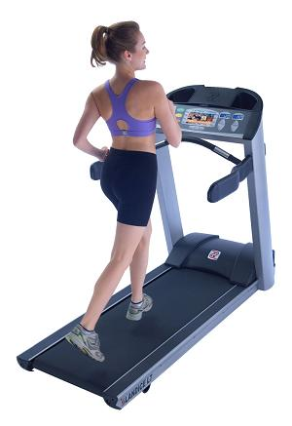
Press Release Summary: Totally Fitness announce that the Landice Treadmill, America’s number 1 rated treadmill, is now being made available through Harrods and the 5 other Totally Fitness stores, as well through the Totallyfitness.co.uk website
Press Release Body: Totally Fitness have announced they are making the Landice Treadmill now available in Harrods and the 5 other Totally Fitness stores, as well through the Totallyfitness.co.uk website.
Landice Treadmill's are the machines used to train the US military and the Cirque de Soleil acrobats in Las Vegas, so they’re certainly built to last. Given this, Totally Fitness offering a Lifetime warranty on all parts – the first time this has been done for any treadmill in the UK.
Landice treadmills have been the number 1 rated machine for five years by Consumer Reports, highly rated in Runners World, Treadmill Dr., Treadmill Guru, etc.
According to Men’s Journal, in its 'Gear of the Year' issue, it said: "Looking to the automotive world for inspiration, Landice created a treadmill with the brushed aluminum finish of an Audi TT, the round, red-and-white analogue gauges of a ’55 T-bird, and the audio console of a Lexus SC 430. Under the hood it’s powered by a 3 hp engine that exceeds health club standards and pushes its top speed to 12 mph – a very respectable pace."
According to Men’s Fitness, “If you want the best - and can afford it - the L7 is the bad boy.”
Landice have been building treadmills for over 35 years. Treadmills are all they do and this focus comes through in the quality of the product.
There are initially two Landice Treadmills available (the L7 and L9) with more to be available shortly.
The Landice L7 Club Treadmill with the Pro Sports Trainer Console provides both built-in and user defined fitness programs and a program progress indicator, so that users are guided through their exercise session. As standard, there is a wireless-chest-strap heart-rate monitoring system and a numeric keypad with Quick-Speed and Quick-Grade controls. Engineered with modern technology and uncompromised materials, the Landice L7 treadmill provides users with the features and reliability that they need for the best results.
The Landice L9 Club Treadmill comes with the Cardio Trainer Console. This covers the features of the Pro Sports Trainer Console but with time, distance, and calorie goal programs, 3 Fitness tests (Balke, Firefighter, Army) and 2 built-in heart-rate monitoring programs. As standard, there is the Accutrack contact heart-rate monitoring system. The other difference with the Landice L9 treadmill is that it is longer and wider than the L7.
The Landice Treadmill completes the Totally Fitness best-of-breed category range, alongside the Octane Elliptical Cross Trainer and the LeMond Exercise Bike. All are exclusive to Totally Fitness and all are available now.
Web Site: http://www.totallyfitness.co.uk/
Contact Details: PR contact:
Elliot Zissman
Director
Totally Fitness
Unit 7
1000 North Circular Road
London
NW2 7JP
United Kingdom
+44 (0)20 8438 8515

