Uncommonly Cute launches Spring 2008 line
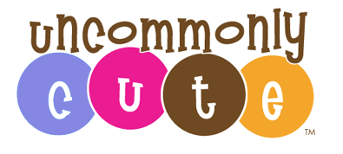

Released on: January 10, 2008, 7:11 am
Press Release Author: Uncommonly Cute
Industry: Retail
Press Release Summary: New Baby Clothes and Toddler Tees From Uncommonly Cute. Dressing Your Lil’ One Has Never Been So Much Fun.
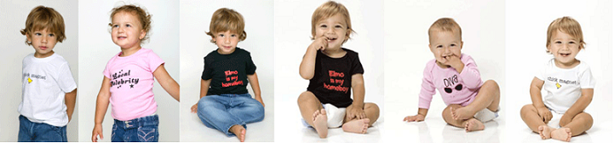
Press Release Body: (New York, NY) January 10, 2008 - Uncommonly Cute, a online children's boutique retailer of baby clothes, hip children's clothing and cool baby gifts, today introduced their Spring 2008 line.
New Designs include an adorable ‘Copyright 2008’ onesie, for all the new years’ babies just born. Uncommonly Cute’s ‘Lil Republican’ and ‘Lil Democrat’ onesies and tees are perfectly timed for the hot primaries currently taking place. Additionally, babies can show their Valentine’s Day love in style with their adorable ‘Got Love?’ tee.
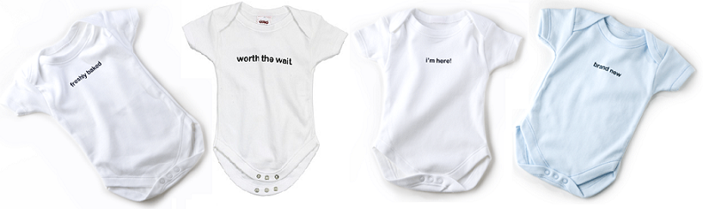
Offering newborn sizes through children's size 6, UncommonlyCute.com aspires to provide unique yet must have attire for little ones. In addition to these new baby clothes and children's clothing, customers searching for twin apparel will find an adorable selection of onesies specific to the sense of humor that comes with being a parent of twins. Onesies featuring claims such as "Perfect Pair" or "Baby Squared" make one of kind gifts for the mother to be or for parents to celebrate their little bundles of joy.
Inspired by the lack of stylish and unique clothing available for babies and toddlers, Uncommonly Cute came to fruition. As a solution to the commonly uncute clothing and personality-free attire for babies and children, the company began by creating no fuss, yet witty tees for children and babies. Made from 100% combed cotton, all onesies and t-shirts made by Uncommonly Cute are sure to delight the babies' and appeal to the practical, yet fashion conscious moms. All clothes are affordably priced, machine washable and made in sweatshop-free American studios.
"We strive to bring the best of fashion statements to your little one's wardrobe at affordable prices," stated Allison Friedland, Founder of Uncommonly Cute. Quality, style and affordability don’t typically blend well together, but at Uncommonly Cute, our mission is to bring affordable, yet unique style to families across the globe," Friedland concluded.
Supplying baby clothes to boutiques all over the country, Uncommonly Cute prides itself on making quality tees destined to spark a smile, make heads turn or even generate celebrity buzz. For more information of unique baby clothes and toddlers tees, please visit www.uncommonlycute.com.
About Uncommonly Cute
Uncommonly Cute is an online children's boutique specializing in baby clothes, hip children's clothing and cool baby gifts. The company retails stylish baby clothes and hip toddler tees for children sizes newborn through size 6. Uncommonly Cute supports multiple charities including Room to Grow, R Baby Foundation and The Breast Cancer Research Foundation. Privately held Uncommonly Cute is headquartered in New York, NY. For more information, please visit www.UncommonlyCute.com.
Web Site: http://www.uncommonlycute.com
Contact Details: Allison Friedland
President
917-217-2150

