Warner Leisure Hotels offers romantic kids-free Valentines breaks this year


Released on: January 30, 2008, 3:53 am
Press Release Author: Warner Leisure Hotels
Industry: Consumer Services
Press Release Summary: Warner Leisure Hotels offers exclusively kids-free breaks for romantics looking to get away with their loved one this Valentines
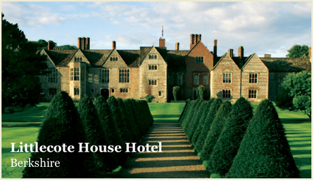
Press Release Body: This year, as Valentine’s Day falls in the middle of half term, hotels up and down the country will be packed with kids. This means little escape for romantics looking to get away with their loved one, as they are surrounded by children excitedly enjoying their school breaks. This is why Warner Leisure Hotels has decided to offer relaxing and romantic short breaks set in some of the UK’s most beautiful countryside and coastal locations, exclusively for adults.
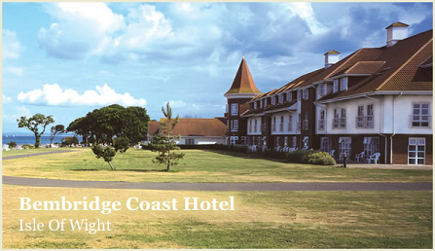
Warner Leisure Hotels has 13 available as part of their new Valentines breaks, ensuring there is a property and location to suit every romantic couple, from the grandeur presented by a magnificent historic listed mansion, the personality and charm of a character hotel through to the treasured familiarity of a traditional seaside resort.
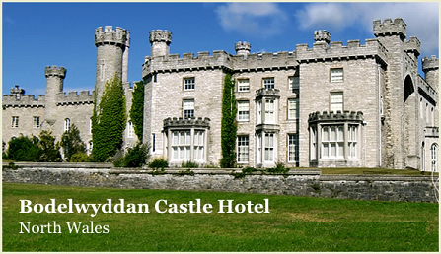
The list of hotels included in the offer has been carefully chosen to offer a wide selection of activities, lavish menus and great entertainment, in a range of truly romantic locations, like the beautiful Littlecote House in Berkshire, where Henry VIII wooed Jane Seymour, his future bride. Lovers can explore its ancient rooms, including the historic Cromwellian chapel and breathtaking Dutch parlour, or enjoy a romantic stroll in the stunning gardens along with a special candlelit four course gala dinner, fireworks, champagne, a red rose and nightly live entertainment.
Another of the venues being made available is the magnificent Bodelwyddan Castle, with its stunning setting and glorious views along the North Wales coastline which makes it the perfect place to spend a romantic break. The Valentines offer also includes a special candlelit dinner, heart shaped chocolates and a red rose.
A third of the jewels being presented is the Bembridge Character Hotel on the peaceful and picturesque Isle of Wight, which has a rugged, windswept beach on its doorstep, and makes for the perfect secluded hideaway. Included in the Valentines break offer is a cocktail in the specially themed bar along with a gala dinner celebration on the Saturday night.
The Valentines break packages have been specially designed for romantics to be able to truly getaway and enjoy each others company and all include a sumptuous three course dinner every evening, a comfortable en suite bedroom, a full English breakfast, live nightly entertainment and numerous daytime activities and leisure facilities.
Web Site: http://www.warnerbreaks.co.uk/
Contact Details: Frances Pardell
PR Manager
Warner Leisure Hotels
1 Park Lane
Hemel Hempstead
Herts
HP2 4YL
01442 203422

