ARTIFICIAL IMAGINATION
A fascinating new book combining Humor, Technology and Philosophy
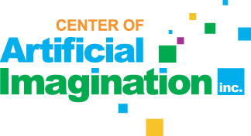

Released on: February 18, 2008, 1:00 pm
Press Release Author: Center of Artificial Imagination, Inc.
Industry: Media
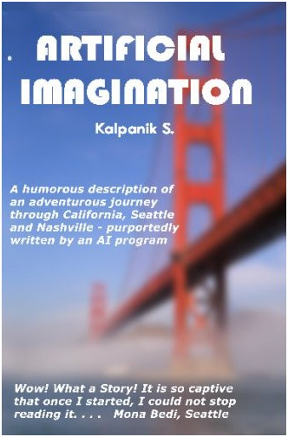
Press Release Summary: A captivating new book, called “Artificial Imagination”, purportedly narrated by an AI computer program, mixes technology and art together into a fascinating combination of humor, technology and philosophy.
Press Release Body: (SAN DIEGO, California) – Computers can “think”, play chess and solve problems but can they feel, create art or write a book? Can they imagine?
A captivating new book, called “Artificial Imagination” purportedly narrated by an AI computer program, mixes technology and art together into a fascinating combination of humor, technology and philosophy.
The book follows one high-tech immigrant’s journey through the United States – as he graduates from the University of California, Davis and then wanders through Silicon Valley/San Francisco, Seattle, Nashville and finally back to Southern California in his quest to find his dream job; and a place which he could call his home.
“Technology is all brain, no heart, all cold logic, and no warm soul – or is it?” said Will Curl, Ph.D., Lecturer in English at University of Wisconsin, Fox Valley who authored the foreword for the book. “This gem of a book reminds us that technology could not exist were it not for boundless creativity, and it does this in such a way as to also remind us that without that very same creativity, there would be no art, no poetry.”
The story is written with a very entertaining tone and is infused with splashes of humor, wit and the immigrant experience.
“Identifying what is real and what is an illusion is complicated“ said Sonia Talreja, the Publisher and Vice President of Sales and Marketing, Center of Artificial Imagination, Inc. “The author make us think about such questions in our minds. In the process, he also presents us with captivating details of the lives of an immigrant family adapting to local customs and people in various parts of the US.”
The book includes professional photographs of locations across the United States including San Diego, San Francisco and the University of California, Davis campus in California; Seattle and Bellevue in Washington and Nashville and Brentwood in Tennessee.
Many of these photographs were taken by Colin Zheng, a graduate student studying the fascinating area of computational photography at University of Washington in Seattle.
“Imagine waking up in the morning and wondering whether you were in New Delhi or New York, San Francisco or Seattle?” said Lyndi Reiber, a Graphic Designer and a member of San Diego Mensa. “The author is able to use humor and philosophy to bring out the confusion caused by having to constantly move and adapt to new places”.
“This book is really good, I could certainly relate to what the author goes through in his story” said another Hi-Tech immigrant, Neerav Berry, co-founder and COO of Cellmania, a company based in Silicon Valley, California.
An excerpt:
“The video, true to its name, depicts Faith Hill, who lives in my neighborhood and is younger by less than a year to me, in tears.
It has been known since ancient times that sight of a damsel in distress, a woman in tears incites strong feelings of chivalry among men of ages between 10 and 60. The male brain is somewhat weird in that regard. Show us images of handsome, masculine men in tears and we will turn our faces away in disgust! Show us a helpless woman in tears; we will try our best to help her. “
This book can be purchased at Amazon.com.
For interviews with the author, or for wholesale orders, please contact Center of Artificial Imagination, Inc. at info@artificial-imagination.com or by phone at 858 731 6225.
For more information about the book, the author or other fascinating aspects of Artificial Imagination please visit the website for Center of Artificial Imagination, Inc. at www.Artificial-Imagination.com.
Web Site: http://www.Artificial-Imagination.com
Contact Details: Sonia Talreja
Director of Marketing
Phone: 858 731 6225
Fax: 480 393 5591
Email: sonia@artificial-imagination.com
Center of Artificial Imagination, Inc.
14525 SW Millikan Way, Suite 34557
Beaverton OR 97005

