ATV and Motorcycle Enthusiasts Rejoice


Released on: February 16, 2008, 12:31 am
Press Release Author: February 16, 2008, 12:31 am
Industry: Automotive
Press Release Summary: The ONLY source for legal ATV - MC license plate replicas anywhere. Official State design or your own custom design.
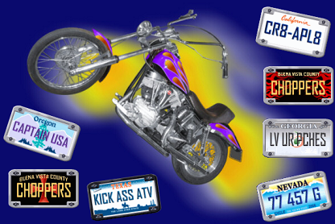
Press Release Body: ATV and MOTORCYCLE ENTHUSIASTS REJOICE! At last, Custom or Replica U.S.A. State License Plates are now available for up to 50 years back.
Hollywood's only TV and Movie supplier of replica license plates for the last 25 years, now offers their service to YOU. Lost or damaged older plates, custom design, or just a little extra jazz to set your ride off? Here’s your $36.95 solution.
February 1, 2008 (Press Release) -- It had to happen sooner or later. Too long now MC and ATV riders and buffs have suffered from not being able to crown their glory with period license plates. Millions have lost their plate and still others want a special plate that set off their pride and joy.
One problem is that when a State comes out with a new issue, that’s it for the old one. All the blanks that they have are tossed out and it’s tough luck trying to get a replacement.
Well, it isn’t a problem any more. Legal, high-quality replica plates - with accurately detailed artwork including the original fonts used - are now available for the first time at http://www.CR8-APL8.com. A Hollywood TV and movie prop master for 25 years has been making them for the public for the last year.
These are standard size plates, 4” X 7” ... and they look just like the originals. Actually from a foot and a half away you can’t tell the difference. So busy is http://www.CR8-APL8.com that they now run three shifts, 24/7 to keep up with the demand.
DMVs across the nation now refer hopeful MC – ATV enthusiasts with damaged or missing plates to the Internet as the only alternative to their plight. CR8-APL8.com has helped out thousands with their problem. The new process that they have developed does not use paint or even ink. Gases are fused onto the metal to give a luster and sheen like Stop and Yield signs have. This process not only puts an unqualified luster on the plate and letters but the license plate actually gets brighter in definition as the sun gets to it - which means that your replica plate from CR8-APL8.com has a longer life than the original plate.
So now, no matter whether you want a Chips, Bat Cycle, or State plate replacement, The MAD Greek at CR8-APL8.com can make one for you. The site shows about 200 examples and these guys are so cool that after you order one they send you a jpg image for verification that you can save to your computer and use for stationary ... or whatever. Price? A phenomenally low $36.95 for at least a year and you can’t beat that price for something that doesn’t exist anywhere else on the planet. The site is a clever motorcycle theme including selected audio snippets. Get yours today at http://www.CR8-APL8.com. As in CR8 (CREATE) A (A) PL8 (PLATE)... or e-mail the MAD Greek at info@CR8-APL8.com
For more information:
info@CR8APL8.com
Visit our website: http://www.CR8-APL8.com
Web Site: http://www.CR8-APL8.com
Contact Details: CR8APL8
POB

