Atlanta Roofing Company Offers Best Prices
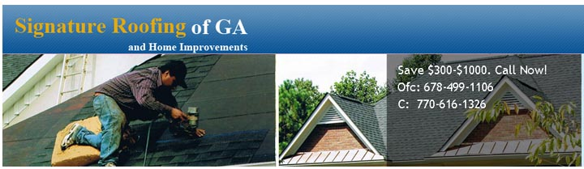
Released on: February 22, 2008, 2:54 pm
Press Release Author: Signature Roofing of GA
Industry: Construction
Press Release Summary: We guarantee that we will beat any other reputable company's estimate by between $350.00 and $1,000.00.
Press Release Body: Signature Roofing of GA is one of Atlantas most respected and dependable roofing companies. The family based business was established in 1993. Recently, Signature Roofing of GA decided to save homeowners more money than it had in the past by offering free estimates. Please request a free estimate at http://signatureroofingofga.com/free_estimate.htm, and by guaranteeing that they will beat any other reputable company's estimate by between $350.00 and $1,000.00 minimum.
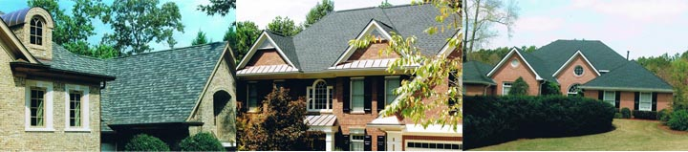
When interviewing a spokesperson for the business, he pointed out exactly what they could offer homeowners: "We specialize in all aspects of residential roofing: Asphalt, Bitumen, and metal. We provide homeowners with emergency tarps, and we install custom fit, manufactured skylights. We manufacture 5" and 6" seamless, aluminum gutters and we give a lifetime warranty on our gutter cap. We do interior and exterior painting, and we offer a double pane, low-E, and argon gas filled aluminum window. We even do carpentry work which includes building decks and additions."
"After being raised in the business, I decided to let the legacy live on and that is why I continue to build this company based on three principles: 1. We offer the best materials on the market; 2. We do all work per code, and 3. We guarantee the best prices of any other reputable company." -David Alan, Co-owner.
Because Signature Roofing of GA has studied their competitors, they guarantee to save homeowners money because they keep their profit to a minimum.
"Our philosophy is that we will give you the best of everything, even the best prices, and guarantee to exceed your expections. By doing so, we know that we will establish a long-term relationship and when you need any other home project done: windows, painting, gutters, or carpentry, then you will remember what Signature Roofing of GA did for you in the past and give us another opportunity to earn your business." Nadia Shelton, co-owner of Signature Roofing of GA, interjected, "The most important thing to our company is treating people the way we would like to be treated."
Signature Roofing of GA asks that you check out their website at www.signatureroofingofga.com. You will find a wealth of information available for home owners, from their testimonials, roofing 101 information, frequently asked questions, and even a portfolio of work they have done for roofing and home improvements.
To receive a free estimate you can call 678-499-1106 or 770-616-1326. Or fill out the contact form at: http://signatureroofingofga.com/free_estimate.htm
Service areas by county include: Batow, Carrol, Cherokee, Cobb, Dekalb, Douglas, Fulton, Gwinnett, and Paulding.
"Please give us the opportunity to earn your business." -Nadia and David Alan
Web Site: http://signatureroofingofga.com
Contact Details: To receive a free estimate you can call 678-499-1106 or
770-616-1326. Or fill out the contact form at:
http://signatureroofingofga.com/free_estimate.htm

