Boots launches full No7 Protect & Perfect range after anti-ageing serum phenomenon


Released on: February 28, 2008, 7:12 am
Press Release Author: Carrie Eames
Industry: Healthcare
Press Release Summary: As a result of the phenomenal success of the No7 Protect & Perfect Beauty Serum in 2007, Boots has launched a full Protect & Perfect skincare range.
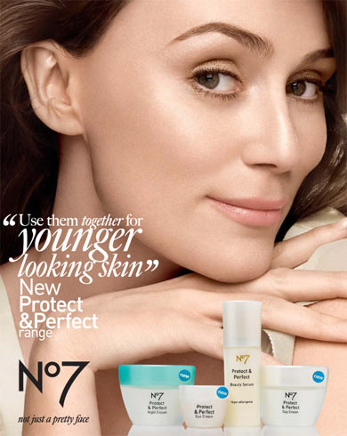
Press Release Body: After the amazing success of the No7 Protect & Perfect Beauty Serum in 2007, Boots has responded to demand from the British female population and has launched an entire Protect & Perfect skincare regime.
Women told Boots that they wanted a whole facial skincare regime based around the Protect & Perfect formulation, not just the Beauty Serum and so Boots has launched a range that has even more active ingredients working together to firm fine lines and wrinkles as well as making skin look younger and feel smoother.
The range has been formulated using an optimum blend of next-generation antioxidants. These help protect the skin from damaging exposure to a wide range of free radicals such as the sun’s rays, pollution and cigarette smoke. Plus because skin repairs and regenerates itself over time, ingredients have been added that work no matter what phase skin is in. Each of the products in the range contains the Protect & Perfect firming complex, with lipo-peptides and white lupin extract to help improve the appearance of skin after UV damage to collagen and elastin.
The No7 Protect & Perfect range has been expanded to include a day cream moisturiser, which includes SPF 15, the No7 Protect & Perfect Night Cream, an eye cream and a body moisturizer.
No7 Protect & Perfect Beauty Serum shot to fame in the summer of 2007 after a television documentary found it to be a skincare product proven scientifically to repair photo-aged skin and improve the fine lines associated with photo-ageing. Sales of the wonder cream increased by nearly 2000% the day after the TV programme, with 13 being sold every minute. At the height of the public’s frenzy for the serum, Boots’ production facilities were working around-the-clock to hit the target of 1,000 bottles an hour.
About Boots
Boots is the UK’s leading retailer of beauty products, skincare products and health products, with thousands of products from prestigious brands, as well as exclusive brands that can’t be found anywhere else in the UK, either on the high street or online.
Boots Pharmacy Superintendent is responsible for healthcare advice provided in relation to Pharmacy medicines and other healthcare advice located within the Boots Pharmacy pages of Boots.com. Boots.com is the trading name of Boots.com Direct Limited (VAT no. 116 3001 29) an Alliance Boots company. All other information and advice on boots.com is the responsibility of Boots.com Direct Limited.
Web Site: http://www.boots.com/
Contact Details: Boots PR Contact:
Carrie Eames
PR Manager
Boots
D90E F07
Thane Road
Nottingham
NG90 1BS
0115 959 5995

