Displaysense to provide innovative storage solutions for Hull students


Released on: February 5, 2008, 6:28 am
Press Release Author: Displaysense
Industry: Retail
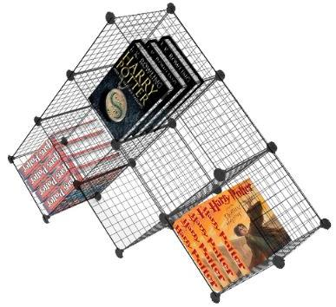
Press Release Summary: Due to high interest rates, and ever increasing energy costs, a student accommodation agency in Hull have turned to Displaysense to provide innovative wire cube displays as a unique affordable storage solution for use throughout their properties
Press Release Body: Due to high interest rates, ever increasing energy costs, and talks of an economic down turn, a student accommodation agency in Hull have spent £11,000 on innovative wire cube displays from Displaysense as a unique affordable storage solution.
Displaysense sell a wide range of cube displays and premium glass shelving displays but it has been within the first 3 weeks of 2008 that demand for their wire cube displays has gone through the roof. With over 40 designs currently available, the wire cube displays have proven to be popular with offices and shops; however a student accommodation agency in Hull has recently purchased £11,000 worth as flexible storage solutions for their student homes.
The £11,000 was spent on the wire shelving units in an attempt to provide ample storage for today’s students on the move. With fears of soaring interest rates, escalating energy costs and the downfall of the UK economy, the student accommodation agency decided to order enough of the wire cube displays to fill 35 of their homes as an economic solution for storing shoes, kitchen equipment and books.
Steve Whittle, marketing manager at Displaysense said “We initially intended these innovative wire cube designs to be used by retail stores as display units but we also knew because of their adaptable nature they could be used for a whole range of solutions. We’re delighted that they are going to serve as an affordable storage device for students.” Steve commented further by saying, “The housing agency are very smart buying these wire cube displays as they are so hard wearing and they are a great investment that will last for a long time with many students potentially ending up using them over a number of years”. The housing association are planning to keep the wire cubes in use for a five year period and will suggest that these shelving units could be used as a bedside table, filing tray or bookshelf.
It is believed that these shelf displays will be provided to the students to use as they wish. One student has even said she will use a singular cube to transport books to and from the library, as carrying the books by hand can be a struggle as essay deadlines loom.
Other student housing associations in the North West have also taken interest in the wire shelf display as word of mouth spreads across the country. Whether used as a laundry bin or a place to put the dirty dishes, parents can rest easy knowing that their children may finally shake off the stigma of living like a student.
About Displaysense
Displaysense was established in September of 1978 as a manufacturer of quality point of sale displays. They have a wealth of experience in design and manufacturing and have been able to develop their ever growing standard range of over 1500 displays. The range is now hugely diverse including brochure, poster and leaflet displays, window mannequins, modular shelving units, exhibition displays and general display boxes and trays.
Displaysense works with a large range of clients including, retailers (multiple and independent), blue chip corporate clients, cafés, bars, restaurants and night clubs, shop and office fitters, marketing and promotions companies, designers and architects, product distributors, exhibition contractors and exhibitors, printers, councils and NHS trusts, charities, schools and universities.
Displaysense is a one-stop-shop for retail display products and all shop display, catering display and exhibition display requirements.
Web Site: http://www.displaysense.co.uk/
Contact Details: PR contact:
Displaysense PR Contact Details
Steve Whittle
Marketing Manager
Displaysense
Unit 5
Raynham Close
Bishop's Stortford
Hertfordshire
CM23 5PJ
UK
0845 2008139
http://www.displaysense.co.uk/

