Dubai Holding and the British Museum to bring Word into Art exhibition to the UAE
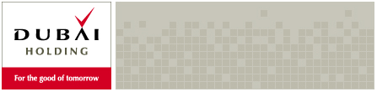

Released on: February 11, 2008, 2:57 am
Press Release Author: Dubai Holding
Industry: Entertainment
Press Release Summary: Dubai Holding and the British Museum showcase Arabic calligraphy artists of the modern Middle East at the Dubai International Finance Centre 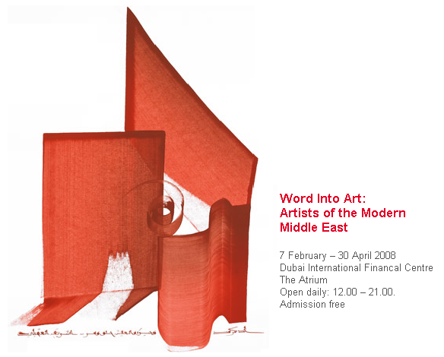
Press Release Body: Following a successful run in 2006, the British Museum and Dubai Holding have announced that the exhibition Word into Art will be on show in Dubai until the end of April 2008. Admission is free.
The Word into Art exhibition at the Dubai International Finance Centre celebrates the creativity of Middle Eastern artists, focusing on the way writing has been used in modern art. From traditional Arabic scripts to present day graffiti, artists across the region have found innovative ways of using script. They write verses from the Qur’an, lines of poetry, use texts to highlight their preoccupation with politics, or simply show their delight in the shape of the Arabic letter. It is this rich diversity of approaches that this exhibition seeks to examine.
Mohammad Al Gergawi, Executive Chairman of Dubai Holding said, “I’m glad that Dubai Holding has taken this opportunity to partner with The British Museum to host such an excellent exhibition. In the Middle East, Dubai Holding is committed to encouraging innovation in all aspects of our society and developing the talents of the artistic community in the region is a very important part of this goal. This exhibition demonstrates just how impressive these talents are.”
The majority of works in the exhibition are from the British Museum, which uniquely amongst British institutions has been acquiring works by artists from the Middle East and North Africa since the mid-1980s. The exhibition is divided into four sections. Sacred Script, explains the relationship between Arabic script and the religion of Islam, showing the enduring vitality of the Islamic calligraphic tradition today.
The innovative work of Ahmad Moustafa, Kamal Boullata, Khaled al-Saai, Fou’ad Honda, Siah Armajani and Erol Akyavas are included in this section. The powerful literary tradition of the Middle East, the enduring appeal of ancient and modern Arabic and Persian poetry, and the work of Sufi writers is evoked in Literature and Art.
In Deconstructing the Word, works by Dia Azzawi, Hassan Massoudy, Etel Adnan, Abdallah Benanteur, Shirin Neshat, Farhad Moshiri, Ebrahim Bousaad, Jamal Abd al-Rahim and others reveal how artists seek to find ever more inventive ways of writing or illustrating these famous texts.
Letters and words are sometimes legible but more often they are not, having been turned into beautiful abstract patterns by artists as diverse as Rachid Koraichi , Michal Rovner, Faisal Samra, Parviz Tanavoli, Yussef Ahmed and Ali Hassan. Finally, Identity, History and Politics looks at the ways in which the words embedded in these works can provide society with real snapshots of history as well as revealing reactions to the region’s devastating conflicts during the past few decades. Included here is the work of Kareem Risan, Walid Raad, Laila Shawa, Sabah Naim and Khusrau Hasanzade.
Neil MacGregor, Director of the British Museum commented, “This will be the first time that the British Museum has sent an exhibition to the Middle East. Dubai is the perfect choice as it is a thriving centre for contemporary art. It is wonderful that Dubai Holding have given us the opportunity to stage this important exhibition in such an important city”.
About Dubai Holding
Dubai Holding was launched in October 2004 to consolidate the various large-scale infrastructure and investment projects in Dubai, as well as to identify opportunities to develop future major projects that will benefit the UAE and the region.
The company was created with the goal of providing a better future for all through the range of life-improving industries it is involved in. Each Dubai Holding operating company focuses on key areas which dynamically support the development of Dubai as a world-leading hub for commerce, leisure and finance.
Dubai Holding has created a strong foothold in various industries, developing pioneering initiatives spanning numerous sectors including healthcare, technology, finance, real estate, education, telecommunication, entertainment & leisure, energy, communication, industrial manufacturing, biotechnology, hospitality and aerospace.
Dubai Holding entities include: Dubai Internet City, Dubai Media City, Dubai Healthcare City, Dubailand, Dubai International Capital, Dubai Industrial City, Dubai Properties, Sama Dubai, Dubai Group, Dubai Energy, Dubai Knowledge Village, Dubai Outsource Zone, International Media Production Zone, e-Hosting Datafort, EMPOWER, Jumeirah Group, Dubiotech and Dubai Studio City.
Web Site: http://www.dubaiholding.com/
Contact Details: PR contact:
Malcolm Ward
JiWin
Al Thuraya Tower 1
First Floor
Dubai Media City
PO Box 39333
Dubai
United Arab Emirates
Tel: +971 4 3613576
Fax: + 971 4 3888001
http://www.dubaiholding.com/

