First Collectable MMORTS Announces Retail Distribution Partners
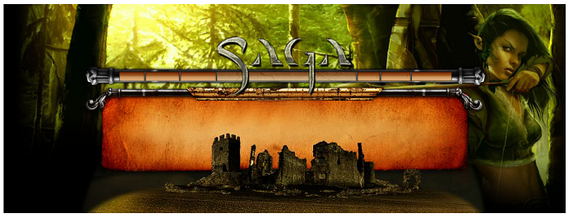

Released on: February 5, 2008, 4:33 pm
Press Release Author: Silverlode Interactive
Industry: Computers
Press Release Summary: Silverlode Interactive announced today a retail product for its online collectable game SAGA and the names of distributors to hobby stores in the US and Canada.
Press Release Body: Silverlode Interactive has partnered with Alliance Game Distributors, GTS Distribution, Diamond Comics and ACD Distribution to distribute its collectable online MMORTS SAGA to over 4000 hobby and comic book stores in the US and Canada. SAGA will be distributed in a retail display containing the game CD, a registration code and 3 booster packs. Individual booster packs will also be available. Each booster pack will include a card with a code that may be unlocked online to receive a virtual pack that will contain a random assortment of spells and troops.
Here’s what happens when you open a SAGA booster: you’ll reveal one of ten random cards, each representing a specific pack type, some of which are less common than others. Some of the specialty packs are the five faction packs, double-rare packs, dragon packs, spell packs… This makes the retail version more exciting than the online purchase.
Following the success of Eye of Judgement and MapleStory, the SAGA retail product will allow Hobby store owners to carry a virtual collectable game. “Hobby Stores who first spurred our imaginations with role playing games have seen a decline in sales with the proliferation of online MMO worlds, and the same decline is now being seen in collectable game sales as more and more games move online. But SAGA turns the tables, providing a retail product to the people who brought us collectable games in the first place,” said Jason Faller, Executive Producer for Silverlode Interactive.
Unlike traditional RTS games that have 10 or 20 different units, the first SAGA set contains over 100 unique troops and over 50 spells in varying rarities. The common troops may be used by any of the five warring factions while most of the uncommon and all rare troops and spells are faction specific. Only the War faction can use Fiery Catapults, for example. Unlike traditional RTS games, troops in SAGA gain levels through questing and may be equipped with powerful weapons and armor.
Retailers are encouraged to contact their distributor before the pre-order deadline of February 22nd. Both products are currently scheduled to ship to distributors on March 14th.
About SAGA – SAGA is a persistent world RTS in an epic fantasy setting. Players collect troops, build armies, conquer new lands and build up kingdoms, complete with resource collection, city building and peasant management. SAGA’s features include massive armies, multiplayer questing, guild wars, espionage, and an auction house for trading troops and spells.
SAGA has no subscription fees. Players pay as little or as much as they decide, by purchasing ‘booster packs’ of random troops and spells, which are traded and customized to create the strategic army of choice for each player. Visit www.PlaySaga.com
Web Site: http://playsaga.com
Contact Details: Slava Zatuchny
Silverlode Interactive
Tel. (617) 905-8482
Email: szatuchny@PlaySaga.com
URL:www.PlaySaga.com

