Homeward Bound Special-Ops Soldier Rewards Himself!

Released on: February 20, 2008, 3:44 am
Press Release Author: Guilty Customs
Industry: Consumer-Services
Press Release Summary: Special-Ops Solider Ash Spurlin stationed in Afghanistan, rewards his hard work by having custom chopper built by Guilty Customs.
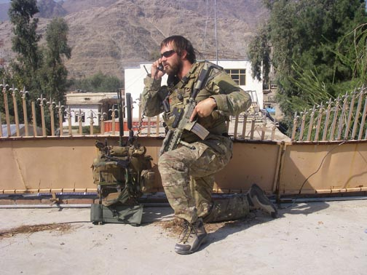
Press Release Body: The sudden clamor of two inbound HH-60 Blackhawk helicopters cut short Ash Spurlin and his squad’s hushed conversations. Spurlin, a Special Ops Squad Leader with the US Army, ordered his men to start their final gear check and to form a circle of security around the landing zone. Once the area was secured, Spurlin marked their position with an infrared strobe. The Blackhawk’s landed easily. Within 60 seconds, both helicopters and men were airborne.
No lights, no talking, just his own thoughts to deal with for the next fifteen minutes of flight. With the side doors open, the cool Afghan air was a nice break from the stifling heat on the ground. Spurlin positioned himself with his legs hanging out the side door of the Blackhawk and used his night vision goggles to scan the area below for possible hostile fire. The wind pushing against his helmet and moving his pant legs only reminded him of riding his Road King back home in California. No lights, no talking, just thoughts of cruising down the Pacific Coast Highway. No sweaty body armor, or M4 rifle, just a t-shirt, boots and his favorite jeans. Instead of the heinous helicopter engine, it was a V-Twin roaring. Right then Spurlin knew that while he couldn’t control when he would return home, he could still make plans for what he would do once there. He would ride his newest custom built chopper!
As his helicopter touched down on the rooftop of a Taliban stronghold, all six men looked at one another, each knowing what the other was thinking, but no one saying a word. Within seconds the men are out, the helicopters are gone, and so are the thoughts of grabbing that V-twins throttle. Anyway, this is a different type of adrenaline rush. The mission completed, Spurlin debriefs his superiors, eats and logs onto his Yahoo account. He is intent on finding from friends in the industry who they’d recommend for his next build. That’s how he found Guilty Customs and Errant, his next and third custom motorcycle.
Errant, part of Guilty Customs “Last Chance” line, caught Spurlin’s attention with its 70’s dragster styled influences. Spurlin comments about his decision to have his next chopper built by Guilty Customs: “Since I had two bobber styled bikes that were similar in looks, I wanted something different, but dependable and affordable. One of my friends told me about Guilty Customs so I called and spoke with Cj. We talked for about an hour. I didn’t feel like as it was a business call, which is when I knew 100 percent, this company was the kind of business I’d always heard my father and grandfather talk about. Not cookie cutter $65,000 choppers or assembly line bikes, but actual one-on-one discussions about my next bike.”
“Having the opportunity to build a bike for Ash is an honor. We are extremely proud that he will be riding a Guilty chopper” says CJ Hanlon, owner of Guilty Customs. “Each time we speak with Ash, either before or after a mission, it poignantly reminds us of the sacrifices these soldiers (and their families) are making to defend our country. Even the companies that supply our parts have a unique interest in this build. Everyone wants to make this bike really special for Ash.”
Spurlin and Hanlon have even started talks about a cross-country ride to raise monies for the widows and families of soldiers killed in battle. It gives us one more reason to want to see this soldier return safely home.
Guilty Customs, LLC (www.guiltycustoms.com) is a custom motorcycle company that is quickly establishing itself in the custom chopper industry by bringing to the public innovative, dependable and affordable custom motorcycles and parts.
Web Site: http://www.GuiltyCustoms.com
Contact Details: Guilty Customs, LLC
407.453.0844
info@GuiltyCustoms.com
http://guiltycustoms.com/blog/
MySpace: http://www.myspace.com/guiltycustoms

