Markansas Enterprises Launches Safety Websites to Protect Your Home and Family


Released on: February 29, 2008, 6:57 pm
Press Release Author: Ken Potter
Industry: Defense
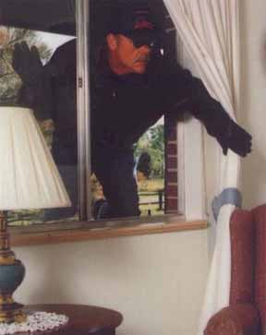
Press Release Summary: We specialize in safety and self defense products to protect your home and family.
Press Release Body: Who hasn’t seen the press about all the muggings, rapes and killings in cities across the United States? Have there been any of these crimes in your city or town? Have you personally been affected by crime? Do you know anyone attending college today? Can you imagine the fear they are experiencing? Are you afraid to walk along down a street or in a parking garage? Is anyone you know looking for ways to adequately protect themselves?
Today, everyone is touched, one way or another, by crime. They have either been faced with crime or know someone that has. The larger percentage of these crimes are committed against women, children and our senior citizens. It is time to fight back.
Markansas Enterprises has been in business for 10 months. We are proudly and steadily building safety relationships with satisfied customers all over the United States.
Our websites include products that serve, not only our law enforcement agencies, but also, the general civilian population. These products include tasers, stun guns, pepper sprays, telescopic batons, child safety products, college safety products, security cameras to protect your home and businesses and many others.
You are sure to find a product to Protect Your Home and Family. Have a look around our websites. There are hundreds of items to choose from. You can also sign up for a Newsletter to keep abreast of safety topics and product specials.
Web Site: http://www.ProtectYourHomeandFamily.com
Contact Details: Contact Details = customerservice@ProtectYourHomeandFamily.com
Web URL’s:
http://www.ProtectYourHomeandFamily.com
http://www.EyesUndetected.com
Company Name = Markansas Enterprises
Address: 45 Lively Lane
Elkton, Maryland 21921
Phone: 800-235-6402
Email: customerservice@protectyourhomeandfamily.com
###

