Robox Studios develops independent game, Orphan Feast, for Adult Swim


Released on: February 12, 2008, 9:13 pm
Press Release Author: Robox Studios
Industry: Entertainment
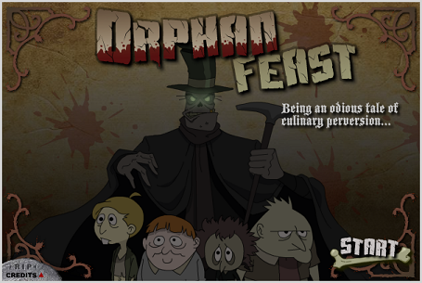
Press Release Summary: Robox Studios takes part in Adult Swim's search for independent games, releasing the action/adventure title Orphan Feast.
Press Release Body: Robox Studios, a games and animation company based in New York, had the opportunity to develop a unique property for Adult Swim, as part of the company's initiative to develop independent online games.
David Pietrandrea, the co-owner and creative director, developed the concept in-house with his partner and pitched it to Adult Swim. The resulting game, "Orphan Feast," combines the world of Victorian London with touches of Oliver Twist, A Modest Proposal, and Jack the Ripper.
"We knew we had something twisted on our hands," says Pietrandrea. "And that it would be a perfect fit for Adult Swim." The player controls a vicious and ragged hired-hand whose job it is to collect orphans on the streets of London, rounding them up to be made into pies to feed the aristocracy.
"We try to develop concepts with a more cinematic approach, making something that implies a back story. It adds depth to the property and, I think, enhances the gameplay experience. We love the idea of creating small worlds for our characters and games to occupy and Orphan Feast was the perfect opportunity for that."
Robox Studios is a start-up in a crowded field, but they're confident in their approach, says Pietrandrea. "We're a new company, but we're focused on our specific goals and our simple philosophy: if it pleases us, it will please the client. That's our golden rule, I'd say. If we're proud of it, we have no doubt the client will be too."
Robox Studios is currently developing projects for The History Channel and the ASPCA as well as dedicating time to in-house game development.
Web Site: http://www.roboxstudios.com
Contact Details: David Pietrandrea, Robox Studios
68 West 10th St. #31, New York, NY 10011
david@roboxstudios.com
646 361 5704

