Skinny Dipping in Salt Water Good for Skin


Released on: February 18, 2008, 9:11 pm
Press Release Author: Karen Porter
Industry: Retail
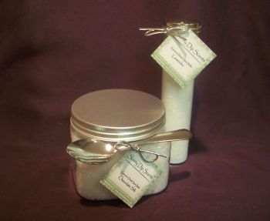
Press Release Summary: Skinny Dip Scents, a division of Scents of Décor, Inc. has launched a new product line, Skinny Dip Salts, a line of premium bath salts. Made from genuine Dead Sea salts, Skinny Dip Salts compliment the company’s existing flagship product line, Skinny Dip Candles.
Press Release Body: Expanding the Skinny Dip brand and “skinny dipping” theme begun with its flagship product line, Skinny Dip Candles, the Skinny Dip Scents Division of Scents of Décor, Inc. has launched a new product line, Skinny Dip Salts, a line of bath salts products.
Skinny Dip Salts are made from genuine Dead Sea salt imported from the southern-most, and most mineral rich, portion of the Dead Sea. Salt from the Dead Sea has been treasured for thousands of years for its high mineral content and therapeutic properties.
The Dead Sea contains salt levels up to 10 times higher than those found in most other salt water bodies. Exceptionally rich in potassium, magnesium, calcium and bromides, salt from the Dead Sea has been coveted since ancient times and is used in spas and treatment centers around the globe for its therapeutic benefits.
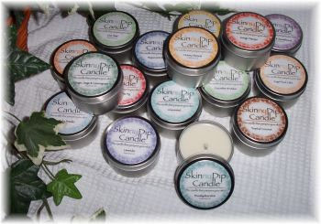
Bathing in Dead Sea salts is often done to help revitalize skin, provide relief from aches and pains, draw toxins from the body, reduce stiffness after exercise or exertion, relax sore or aching muscles, and to help improve problem skin conditions such as acne, psoriasis and eczema. Dead Sea salt baths are also coveted for their ability to soften and rejuvenate skin all over the body.
Skinny Dip Dead Sea Salts are available in over 12 fragrances in three convenient sizes and packaging options. The salts come packaged in a 4 ounce tube convenient for trial or travel priced at $6.95, and a 16 ounce jar, presented with a silver spoon attached for $17.95. For those seeking Skinny Dip Salts without packaging, they are also available for $12.95 in a 16 ounce “bulk” bag.
Skinny Dip Salts, along with Skinny Dip Candles, can be purchased online at the company’s website, http://www.SkinnyDipCandle.com. Site visitors can win Skinny Dip Candles and Skinny Dip Salts by entering the monthly drawing which can be found on the “Enter to Win” page of the website.
Web Site: http://www.skinnydipcandle.com
Contact Details: Skinny Dip Scents by Scents of Decor, Inc.
P.O. Box 394
Cedar Park, TX 78630
(512)258-8300
info@skinnydipcandle.com

