The little Coffee Roasting Company who can Roast Coffee with the best in the world

Released on: February 6, 2008, 5:21 pm
Press Release Author: Island Joe
Industry: Food & Beverage
Press Release Summary: From a gas station in the Florida Keys to the highest rated coffee roasting company in the state of Florida and with several gourmet coffee and espresso blends rating in the top 5% in the world.
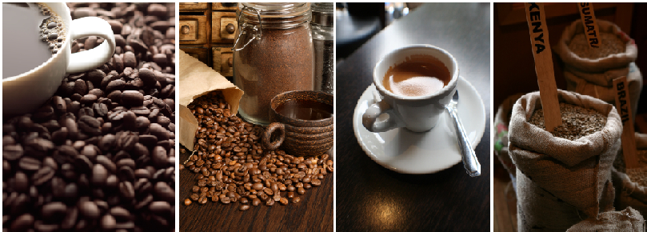
Press Release Body: When the Wells family, a family of islanders located in the Florida Keys, could not find a cup of fresh roasted gourmet coffee “everyday”, well they set off on mission around 5 years ago to do some about it. “We live on an island at the end of the road in Key West, Florida,” stated Joe Wells, co-founder, coffee roaster and father of 3 amazing children, Trey, Brandon and Alexandra. “We deal with hurricanes and flooding, we prepare, we survive and sometimes it is not easy, but we have learned to work as a team, being able to accomplish set goals.”

When ask how this related to being the top rated coffee roasting company in the state of Florida, Wells responded with, “A lot of everything in life has to do with paying attention to detail, are the storm shutters down, are the pets taken care of and where is my coffee. Now, it comes to a point, as sitting out storms, one tends to drink a lot of coffee listening to the radio to find out what is going on with the storms and it was not gourmet coffee, so the idea struck us, as we decided we could roast coffee, plus there are more reasons, but can come at a later date.”
The Wells family started roasting coffee about 5 or so years ago on a $175 home roaster, roasting at home for themselves and neighbors, then customers and tourist who stop by the gas station, then the requests starting coming in for Island Joes Coffee to take home or ship up north, hence the website www.islandjoescoffee.com
Names and roast profiles like Smuggler’s Brew (rated 88 out of 100), Port of Call (rated 87 out of 100), Misty Mornings (rated 88 out of 100), Beemer’s Breakfast Blend (rated 91 out of 100), Black Flag Espresso (rated 90 out of 100), 90 Mile Stretch (rated 90 out of 100) and the latest Island Joe’s Breakfast Blend just rated 91 out of 100, have not only has caught the attention of coffee lovers the world over, but of the international coffee industry. All reviews and rating done a third party, Kenneth Davids, one of the worlds’s leading coffee experts, at Coffee Review.com. As Island Joes online customer base extends to exotic lands around the globe i.e. China, Buka, England, Canada, Puerto Rico, all across the U.S. and a following from the coffee mother land of Seattle is growing. Then some of the finest resort and restaurants in the Florida Keys caught the aroma i.e. Ocean Key Resort and Spa, La Concha (Crowne Plaza), Hyatt Timeshares, Navy Exchange, Café Marquesa, 915, Martins and more, which led to Island Joes Coffee being offered at limited Publix, Albertsons, Walgreens and Whole Foods Markets.
Asking Wells, what he thought their secret was to being recognized by such a diverse worldwide group of coffee drinkers, plus popular supermarket chains and resorts, “Well, one thing for sure is we do not offer 200 or 300 different coffee and espresso beans at our shop, as we do not wish to be Jacks of all Trades and Masters of None. Thus we stick with what we are good at and make sure our products stay gourmet. We consider ourselves a boutique specialty coffee roasting company and we have enough of roasting profile ranges to cover most pallets in the world.”
“It is great honor to receive the high ratings we have, it comes with a great responsibility and it can be very humbling, so we just keep roasting, making sure the cup of coffee you get from Island Joes is as good as or better the last one,” Wells said in closing, “As we live by our motto Born out of Necessity and Crafted with Passion, The Proof is in the Cup.”
Web Site: http://www.islandjoescoffee.com
Contact Details: Island Joes Coffee Roasting Company
425 Southard Street
Key West, Florida 33040
www.islandjoescoffee.com
info@islandjoescoffee.com
Phone - 305-294-1190
Fax - 305-294-1190

