This is how Embassy Suites’ guests say “Do Not Disturb”
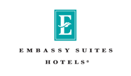

Released on: February 22, 2008, 6:04 am
Press Release Author: Embassy Suites
Industry: Entertainment
Press Release Summary: Embassy Suites Hotels announce the five winning slogans of the Do Not Disturb contest to be hung on doorknobs nationwide
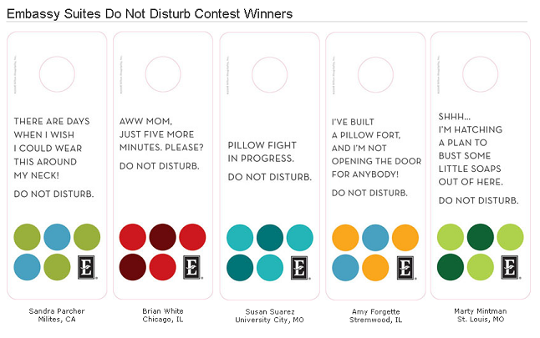
Press Release Body: Embassy Suites Hotels announce the five winning slogans of the Do Not Disturb contest. These guest-designed door hangers will be displayed in all of the hotel brand’s nearly 200 properties starting in March and each winner will receive a three-night stay at select Embassy Suites destinations.
“It was so much fun to be able to create something that will actually appear in hotels all over the country,” said Marty Mintman from St. Louis, Missouri, the winner of the stay at Embassy Suites Waikiki Beach Walk (Honolulu, HI). Marty won with the slogan “Shh! I’m hatching a plan to bust some little soaps out of here.”
The five Embassy Suites Do Not Disturb contest winners have each been awarded a three -night stay at select Embassy Suites locations. In addition to Marty, the other grand prize winners are:
- “Pillow Fight In Progress.” - Susan Suarez, University City, MO - LaQuinta Resort & Spa (LaQuinta, CA)
- “There are days when I wish I could wear this around my neck” - Sandra Parcher, Milpitas, CA - The Embassy Suites New York (New York City)
- “I’ve built a pillow fort and I am not opening the door for anybody!” - Amy Forgette, Streamwood, IL -The Embassy Suites Mexico City Reforma (Mexico City, D.F. Mexico)
- “Aww, Mom. Just five more minutes. Please?” - Brian White, Chicago, IL - The Embassy Suites Washington D.C. Convention Center (Washington, D.C.)
The contest, which ran online at EmbassySuites.com from August – October 2007 was judged by John Lee, Vice President of Brand Marketing and Communications at Embassy Suites; Eric Melkent from Embassy Suites advertising agency Carpenter Sullivan Sossaman (CS2); and Jody Smith, Mike McGilligan and Sayed Hassan, general managers at the Austin Embassy Suites, La Jolla Embassy Suites and Chicago Embassy Suites hotels, respectively.
Guests chose from online designs, images and templates to customize their very own Do Not Disturb design and slogan. Judges were specifically looking for the cleverest and most original Embassy Suites Do Not Disturb signs.
“It was so refreshing to hear the guests’ ideas,” said Jody Smith. “We sifted through more than 7,100 entries and tried to choose winners that had slogans that fit with Embassy’s playful brand personality. The response was overwhelming.”
About Embassy Suites Hotels
Founded in 1984, Embassy Suites Hotels defines the upscale, all-suite hotel segment and has 190 hotels, with an additional 50 in the pipeline. With spacious two-room suites, engaging team members and an inviting atrium environment, guests are allowed to put their feet up and feel right at home.
Embassy Suites Hotels participates in Hilton HHonors, the only hotel rewards program that offers Points & Miles and No Blackout Dates. HHonors members can earn both hotel points and airline miles for the same stay at more than 2,900 Hilton Family hotels worldwide. And with No Blackout Dates, as long as a standard room is available, members can confirm that room using their HHonors points.
Hilton Hotels Corporation is the leading global hospitality company, with more than 2,900 hotels and 490,000 rooms in 76 countries and territories, including 100,000 team members worldwide. The company owns, manages or franchises a hotel portfolio of some of the best known and highly regarded brands, including Hilton, Conrad Hotels & Resorts, Doubletree, Embassy Suites Hotels, Hampton Inn, Hampton Inn & Suites, Hilton Garden Inn, Hilton Grand Vacations, Homewood Suites by Hilton and The Waldorf=Astoria Collection.
Web Site: http://embassysuites.hilton.com/
Contact Details: PR contact:
Dawn Ray
Senior manager
Embassy Suites Brand Communications
Embassy Suites Hotels
755 Crossover Lane
Memphis, TN 38117
US
(901) 374-5954

