User Centric Study Published in User Experience Book Due out March 28

Released on: February 29, 2008, 3:00 pm
Press Release Author: Pamela Stoffregen, User Centric
Industry: Consumer-Services
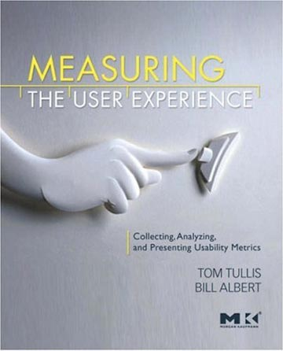
Press Release Summary: Already positively reviewed by Jakob Nielsen, Ginny Redish, and Steve Krug, the book promises to be an exciting addition to the field of user experience research. It will be released on March 28, 2008.
Press Release Body: Associate Director of User Centric, Aga Bojko, recently contributed to a book by T. Tullis and W. Albert entitled “Measuring the User Experience: Collecting, Analyzing, and Presenting Usability Metrics”.
Aga’s case study focuses on the application of eye movement measures, such as pupil diameter, fixation count, and fixation duration, to the quantitative assessment of label design for prescription medication. This research study, conducted in Italy with twenty pharmacists, is one of User Centric’s many eye tracking studies that combine traditional measures of user efficiency and accuracy with the precision and insight provided by additional physiological indicators.
User Centric’s application of eye tracking is used to illustrate the metrics and methodologies described in the book, and show how they can inform real-world design decisions.
Already positively reviewed by Jakob Nielsen, Ginny Redish, and Steve Krug, the book promises to be an exciting addition to the field of user experience research. It will be released on March 28, 2008 and is available for purchase on Amazon.com.
About User Centric, Inc.
User Centric is a global consulting firm that focuses on improving user experience. We apply our expertise to projects involving handhelds, web sites, software, medical devices, print, packaging, and telephony services. Experience, quality, value, global reach and outstanding client services set us apart. Our services include user research, user interface design consulting, information architecture, usability testing, user interface evaluations, eye tracking, and online surveys. Learn more about us at www.UserCentric.com
Web Site: http://www.usercentric.com
Contact Details: User Centric, 2 Trans Am Plaza Dr., Ste 100, Oakbrook Terrace, IL
60181
630.376.1188, www.usercentric.com
pam@usercentric.com

