Yoga Teacher Training Retreat in Bali with Caroline Klebl


Released on: February 10, 2008, 12:43 am
Press Release Author: Source of Yoga
Industry: Education
Press Release Summary: Source of Yoga announces, an Ashtanga Yoga Teacher Training Retreat and Certification course on the beautiful island of Bali. This retreat course will take place from the 2nd to the 30th of August. The course will be conducted by Ashtanga Yoga instructor Caroline Klebl and fulfills the internationally recognized, 200 hour Yoga Alliance Teacher Training standards. For further details visit www.sourceofyoga.com

Press Release Body: 28-day Yoga Teacher Training Certification Course from August 2nd to 30th, 2008:
Immerse deeply in the Ashtanga Yoga practice in this teacher training intensive with Caroline Klebl. This certification course fulfills and surpasses the 200 hour Yoga Teacher Training standards of Yoga Alliance.
Caroline Klebl offers a comprehensive Teacher Training program for teachers, aspiring teachers and dedicated practitioners of yoga. Her teacher training combines the high standards of practice, required by the Ashtanga Vinyasa System with the development of teaching skills necessary to introduce students to Ashtanga Yoga safely and effectively.
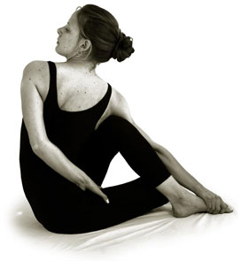
This course begins with a series of workshops focusing on the practice of Ashtanga Yoga. Each participant has a chance to first deeply immerse into their own practice and prepare for Mysore Style practice for the remainder of the course. An Ashtanga Yoga Teacher Training Manual is supplied to each participant. To those who attend all scheduled classes, a 200 hour Yoga Teacher Training Certificate is awarded, at the end of the course.
Topics Include:
Intensive practice of the postures of the Primary Series
The principles of Vinyasa, Bandhas, Drishti and Oujaii Pranayama
Adjustments and Teaching Techniques
Assisting and supervised teaching
Introduction to western Anatomy
Introduction to Ayurveda
Meditation instruction
The Chanting and Philosophy of the Yoga Sutras
Teacher Training Schedule:
Sunrise Meditation: 6am-7am
Ashtanga Yoga (Mysore Style or Led): 7am-9am
Adjustments/Teaching Techniques: 10:00am-12:30pm
Anatomy, Ayurveda & Philosophy: 3pm-5pm
Retreat Location:
This course will take place at a luxury boutique hotel and well-ness resort. The resort includes a yoga pavilion, a treetop meditation deck and a pool. Air-conditioned sea view villas look out onto verdant landscape and down to the sea with sunset and sunrise views. Each villa includes a double bedroom with a private terrace and a parlor leading to an open air bathroom, with a shower and bathtub. Meals are served in the open air dining area or in the garden with spectacular views over rice fields and the sea of Bali. Throughout the retreat, the resort’s talented chefs will present a variety of nutritious dishes featuring Asian, European and Ayurvedic vegetarian cuisine. Special dietary requirements will be catered to individually. The friendly staff will also provide daily room service as well as trips to the near by internet cafe.
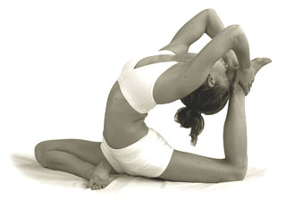
Four Guided Tours on Bali:
Tours of the natural beauty and the sacred Temples of Bali are planned for, on Saturdays and the Full Moon, traditional Ashtanga Yoga rest days.
One Complimentary Massage:
Each participant will have the opportunity to choose from a variety of Ayurvedic and traditional Balinese massages.
Yoga Teacher Training: Aug 2-30, 2008
Double Occupancy: $4800 US
Single Occupancy : $5700 US
The Price includes:
The Ashtanga Yoga Teacher Training Certification Course, accommodation and vegetarian meals at Zen Resort Bali, four guided tours, one Ayurvedic massage and airport transfers from and to Denpasar International Airport.
This all-inclusive retreat package provides each participant with the opportunity to immerse in Yoga practice and focus on the Yoga Teacher Training course.
For additional information and to apply for the course please visit www.sourceofyoga.com
Web Site: http://www.sourceofyoga.com
Contact Details: Source of Yoga
0091 821 428 2686
info@sourceofyoga.com
http://www.sourceofyoga.com

