isABelt Ltd. announces the selection of their Virtually Invisible Adjustable Belt Product for inclusion in the “Everyone Wins at the Oscars” nominee gift bags


Released on: February 24, 2008, 9:57 am
Press Release Author: Elise Wilkins/ isABelt
Industry: Apparel & Fashion
Press Release Summary: isABelt….The ORIGINAL fashion "fix-it" belt! No more back-gap, slippage, or tugging & pulling….. Innovative and Virtually Invisible Adjustable Belt Product
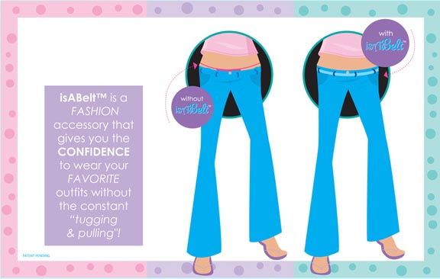
Press Release Body: IsABelt the original invisible belt takes care of belt bulk, back gap and slippage (tugging and pulling) of jeans/pants. isABelt has been included in the “Everyone wins at the Oscars” Nominee gift bags that are produced by Distinctive Assets. The non-winning nominees in the Best Actor/Actress, Best Supporting Actor/Actress, Best Picture and Best Director categories will be personally given a gift bag loaded with thousands of cool and innovative gift items. ...isABelt the original invisible belt takes care of Belt Bulk, back gap and slippage (tugging and pulling) of jeans/pants.
For years, women of all ages and sizes have had problems with the waistline of their pants. Whether it's the low rise pants or a loosely-fitting waist, the waist pops out in the back like a window to your undergarments. No longer acceptable is the former remedy of wearing an unnecessary, bulky belt that only adds pounds to your frame. Why? Because there is finally a solution to this never-ending annoyance: the patent pending fashion accessory that will prevent emBAREASSing malfunctions from happening to you. isABelt is a flat, transparent belt that keeps your pants streamlined against your waist and firmly in place.
isABelt® was invited to be featured in the sumptuous gift baskets being arranged by Distinctive Assets, the well-known provider of over-the-top gift baskets for the major awards shows such as the GRAMMY ® Awards, the Academy of Country Music Awards and the Latin GRAMMY Awards as well as the Kids' Choice Awards and many more. These Gift Bags have become an important part of these awards shows and media including Entertainment Tonight, People Magazine, UsWeekly, The news shows such as the Today Show, often report on the new and hot products that awards show attendees and nominees receive.
isABelt is a thin, virtually invisible adjustable belt that cinches your pants in and eliminates the bunching that other belts create. The unique design of IsABelt allows the customer to customize the fit of the belt with the fit of the waist, and is available in three sizes: small (fits sizes up to 28"), medium (fits sizes 29"-32"), large (fits sizes 33"+) and isABelt + (adjustable up to 50")
isABELT - The Necessary Fashion Accessory
isABelt is the ORIGINAL virtually invisible, fully adjustable belt that keeps your outfit looking great by keeping your pants in place. isABelt is a 1/2 inch wide, strong, flexible belt that seems to virtually disappear when worn. isABelt is comfortable and does a little magic allowing you the subtle assurance that all is secure. isABelt is a utility device a Fashion "fix it" that is… flexible strong comfortable and tested to last.
isABelt is available at select retailers across the country and in Canada, and online at... http://www.isabelt.com. Price available upon request. For wholesale information, please see our website or call 1-866-793-2793.
Web Site: http://www.isABelt.com
Contact Details: isABelt Ltd.
980 Broadway
Suite 136
Thornwood, NY 10594
1-866-793-2793
elise@isABelt.comm
http://www.isABelt.com

