BabyBox.com Announces the Arrival of Swimwear by Snapper Rock and Bella Bliss

Released on: April 17, 2009, 5:07 am
Author: Babybox.com
Industry: Apparel & Fashion
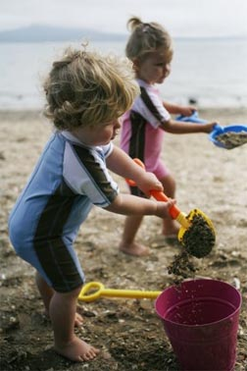
Innovative kids swimwear provides 50 SPF UV ray protection; monogramming adds personal touch
(Darien, Conn.) April 15, 2009 -- www.BabyBox.com, a luxury retailer of high-end crib bedding, baby furniture and baby gifts, announced today the arrival of Snapper Rock swimwear for kids that features innovative fabrics that provide chemical-free ultra violet ray blocking properties with SPF 50. In addition, the entire selection of Bella Bliss swim and beach wear is available with monogramming for the perfect poolside gift.
“Summer is a wonderful time for children and families, with trips to the beach, camping and spending time outdoors, but it requires an extra measure of sun protection that parents can’t always get with sunscreen alone,” said Katherine Type, founder of BabyBox.com. “Thankfully, Snapper Rock has designed a whole line of infants and children’s swimwear that provides 50+ SPF protection to ensure sun safety during those long summer days.”
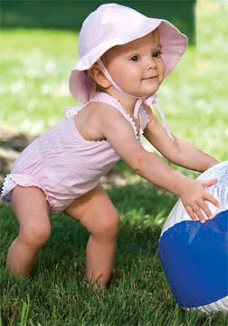
The Snapper Rock swimsuits provide broad spectrum sun protection for little ones whose delicate skin may be sensitive to the effects of chemical sunscreens. The line of UV protection swimwear comes in mix and match two piece swim shorts and swim tops, one piece suits with matching hats that can be purchased for additional top to bottom protection. The performance fabrics block out 99 percent of the suns harmful rays. Suits come in short or long sleeve Choose from pretty pink and floral prints to boys swimsuits inspired by board shorts and wet suits.
Bella Bliss classics for girls comes in pretty bikinis, halter styles and one-piece swimsuits, along with terry cover ups, tunics and hats. Known for its timeless style, quality fabrics and comfort stitching, Bella Bliss makes shopping for baby swimwear fun and easy. Monogramming is available for an additional charge on all Bella Bliss beach wear and accessories.
From developmental toys to baby clothing, crib bedding and nursery furniture, BabyBox.com features an A-list of upscale designers, such as House Inc., Henry & Henrietta, Lulu DK Matouk, Lulla Smith, Gordonsbury, Serena & Lily, Blauen, Sweet William, Lullaby and Baby B, among others.
About BabyBox.com
BabyBox.com is a premier baby gift store for children, ages newborn to 12 months. Offering a specialized selection of luxury baby items, the company prides itself on serving a niche market with a focus on unique and high quality products including adorable baby clothes, crib bedding, nursery décor, quality children's furnishings, baby furniture, custom baby bedding , Moses baskets, bassinets, handmade items, as well as traditional gifts, such as toys, baby blankets and keepsake gifts. In addition to the specialized infant collections, BabyBox.com has expanded its offerings to provide furniture, bedding, décor and clothing for older children. With headquarters in Darien, Conn., BabyBox.com has provided unique baby gifts since 1997. For more information, please visit www.BabyBox.com.
# # #
Contact Details:
Press Contact
Katherine Type
Founder/President
(203) 655-0185

