Drug Rehab in CT uses alternative treatment methods to combat drug addiction and strengthen recovery from drug addiction and alcoholism
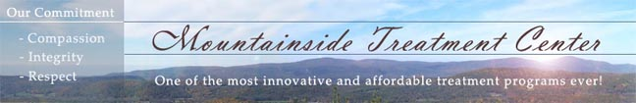

Released on: April 20, 2009, 2:15 am
Author: Mountainside Substance Abuse Treatment Center
Industry: Healthcare
Innovative Drug Rehab uses Yoga, Tai Chi, Qigong and several other therapeutic disciplines to combat drug addiction and alcoholism to build long lasting recoveries. Mountainside Drug Rehab in CT maintains an aggressive approach to innovative and compassionate addiction treatment.
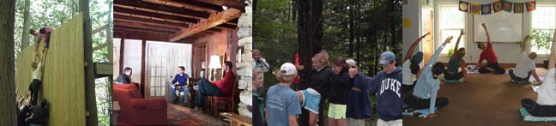
Long time advocate of alternative substance abuse treatment methods, Mountainside Drug Rehab has found that the use of Qigong and Yoga to be highly effective tools at combating addiction and building recoveries. Research studies have shown that extensive drug use clogs the body with toxic debris. TCH, for instance, can lodge in the tissues for years. Qigong’s active stimulation of the lymph system speeds up the detox process, helping to remove impurities from the bloodstream. “Dirty” blood is uncomfortable and often translates into “dirty thinking” which in turn can lead to relapse. Mountainside Treatment Center is always on the cutting edge of treatment methods.
Addiction to drugs diminishes our ability to manage stress and tension. For many months, if not years, after stopping drug use, the internal chemistry remains in turmoil, creating all kinds of dangerous cravings and instabilities. Mountainsides Group-therapeutic activities are invaluable as a partial remedy for these ups and downs. But Mountainsides qigong program can help speed the process of mastering our relaxation response. Qigong’s breathing style, hand movements and postures actively induce a long-lasting relaxation response and a sense of well-being. If you own your own private toolkit for “switching on” feelings of contentment and internal—almost at will—you are less likely to become victimized by your chemical imbalances. From the moment you arrive at Mountainside, you are immersed in a friendly warm environment where you begin to build up your tool kit for staying clean and sober upon leaving.
Mountainsides spiritually-oriented approaches to drug-addiction emphasize the supreme importance of cultivating the skill of “letting go” in our lives. Qigong, in its more meditative forms, is a superb vehicle for training this skill experientially. Emotionally, qigong encourages us to accept and appreciate every emotion as valid and necessary—even fear and anger. By accepting our emotions more readily, we release from them the more easily (attachment and addiction are very close relatives.) Mountainsides qigong program has been very successful and praised by residents. One resident stated that it was a much better feeling than anything she could have achieved chemically.
Mountainsides practice of yoga and naturopathy helps reduce the incidence of relapse after treatment of drug addiction. In a study conducted by the Central Council for Research in Yoga and Naturopathy (CCYRN), the non-meditative approach of yoga and naturopathy in treatment of drug addicts is more effective in detoxification as compared to the allopathic treatment. This is why Mountainside Addiction Treatment Center has incorporated yoga in to its treatment regimen.
Yoga, as well as other alternative therapies, such as meditation are all offered at Mountainside Treatment Center for alcoholism and drug addiction. Yoga has been practiced for the purpose of ending drug abuse with fair results. Many people ask how Yoga helps people quit abusing drugs. The Yogic method for ending substance abuse is very simple. Yoga gives the mind a useful daily purpose, which re-programs the practitioner. And this is why Mountainside has taken on these methods. They simply agree with our healing of the mind, body and spirit.
Drugs fill a void in the mind and body. Even though we disagree with drug abuse, it must be noted that drugs either stimulate or dull the senses. This is one of the main reasons, why someone would try drugs in the first place. Mountainsides group and individual therapies help the individual identify these voids and find other healthy ways to fill them.
Whether it is physical or mental, drug addiction is a result of habit. This habit had to be formed because the addict found the experience pleasurable. Many drug addicts feel they have nothing to live for, and they are not thinking about living for longevity. Mountainside has an educational component like no other in the industry. This innovative treatment program teaches the suffering addict or alcoholic to learn to be “OK” with themselves.
In terms of holistic health, drug addiction is the exact opposite of all forms of Yoga. Along with the other components of Mountainsides treatment modality We offer the substance abusing individual a fair chance at living a clean and sober life.
Yoga is a discipline based upon developing, and maintaining, optimum health. Serious Yoga practitioners tend to eliminate substances, which can be abused, because they do not need them.
Call our admissions professionals at 800-762-5433 or visit our website at -www.mountainside.org/drug-rehab
Contact Details: Mountainside Drug rehab and Alcoholism Treatment Center
800-762-5433
PO Box 717
Canaan, CT 06018
Visit our Website - www.mountainside.org/drug-rehab

