Ernest Jones Launches Gorgeous Gold Jewellery Collection


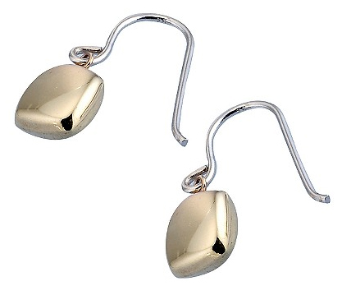
Released on: May 11, 2009, 4:22 am
Author: Tim Lundberg
Industry: Apparel & Fashion
Ernest Jones, the diamond and watch specialist, has announced the UK launch of a new and exclusive collection of designer necklaces, earrings and bracelets, called Gorgeous Gold. Created around the design philosophy of 'When you look good, you feel good and when you feel good, you look good', Gorgeous Gold features a collection of glamorous and affordable jewellery that is both classic and fashionable.
Speaking on behalf of Ernest Jones, Head Buyer Jennifer Dean commented: "The Gorgeous Gold collection is an innovative yet timeless range of jewellery that celebrates the allure and beauty of gold. Featuring a combination of yellow and white gold with smooth shapes and delicate chain detail and enhanced by stunning gems, the collection creates in you a desire to feel, touch and put them on and so we just had to have it for Ernest Jones."
The Gorgeous Gold collection combines the natural shapes of pine needles and pebbles in two-colour gold with black onyx for a truly luxurious finish. This is a classic collection that evokes a glamorous indulgence of days gone by, whilst embracing modern trends and design.
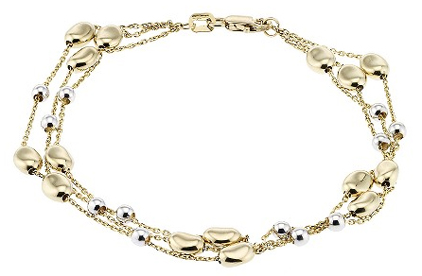
Consisting of a mixture of drop earrings, drop pendants, multi-strand bracelets and necklaces there is great scope for customers to mix and match their Gorgeous Gold jewellery across a variety of looks. This means that this is not only a glamorous collection, but also a versatile one that can be worn for any occasion, with any look. Gorgeous Gold jewellery also covers a wide price range, with something for every budget, ensuring that customers don’t need to break the bank to afford this collection - despite the luxurious designs and materials.
Gorgeous Gold is exclusive to Ernest Jones and demonstrates a customer focused approach that stays one step ahead of fashion. Gorgeous Gold offers Ernest Jones customers desirable, affordable and luxurious jewellery, perfect for those looking for fashionable bargains in the current economic climate.
About Ernest Jones - The Diamond and Watch Specialist:
Ernest Jones, the Diamond and Watch Specialist, has over 200 stores and a retail website. Featuring a wide range of leading brand watches, diamonds and high quality jewellery, Ernest Jones also has a stunning selection of gifts for all occasions. Ernest Jones is part of Signet Jewellers Limited, the world’s largest speciality retail jeweller.
Ernest Jones Contact Details:
Tim Lundberg
Copywriter E-Commerce Marketing
Ernest Jones
Imperial Place 3 Maxwell Road
Borehamwood
Herts
WD6 1JN
0208 207 8312
www.ernestjones.co.uk

