Lookforbeauty.com Sells Customized Pearl Jewelry at Exciting Prices
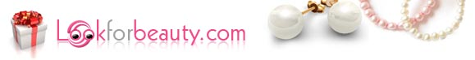

Released on: May 25, 2009, 8:00 am
Author: Jerven Lee
Industry: Apparel & Fashion
May 24, 2009—Hot on the heels of emerging fashion trends, custom pearl jewelry super webstore Lookforbeauty.com announces prices 45-85% below retail stores. This China based fashion jewelry store began selling fashionable freshwater pearl, jade and silver jewelry in 2005. Never looking back, they have managed to lead the industry with trendy, fresh customized pearl jewelry collections at prices their competitors can’t touch.
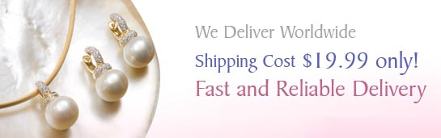
When asked why Lookforbeauty.com has been so successful in such a highly competitive industry, spokesman Peter Lee responded, “Each piece or pearl jewelry that we sell is unique. Combine that with the personalized service we give each and every one of our customers, and it's a win-win situation."
Lookforbeauty.com delivers on its promises with a 100% no questions asked money back satisfaction guarantee. But their dedication to your shopping safety starts way before your bracelets, earrings and necklaces ever reach your door. This jewelry store has a quality control process that ensures that each piece of pearl jewelry is of the highest quality and standards. Dedication like that is not an industry standard. And the webstore doesn’t mind going the extra mile to become your only source for customized pearl jewelry.
When you request special personalization of your pearl jewelry order, the designers at Lookforbeauty.com are eager to work with you to create that special piece of customized jewelry for your wedding or casual wear. While other jewelry retailers charge up to an additional 30% of the product price and take weeks and sometimes months for customization of pearl jewelry, Lookforbeauty.com is happy to oblige your special requests, free of charge and in only a 1-2 day additional time.
With a wide variety of pearl and other fashion jewelry styles, Lookforbeauty.com beats the competition, hands down with a colorful palate of pink, blue, yellow, black and white freshwater and Tahitian South Sea pearl jewelry, in stock and ready to arrive at your front door within 4-8 business days of ordering in most cases. Shipping fees are only $19.99 worldwide and are free of charge on all orders of $150 and over.
Seeking to become your only source for customized pearl jewelry and exciting fashion gemstone collections at affordable prices, Lookforbeauty.com offers stellar customer service. Emails are answered within 24 hours and online chat support is offered during standard business hours.
Hail the new fashion jewelry king! Lookforbeauty.com offers customized pearl jewelry at exciting prices you can’t afford to miss. Complete product inventory and additional information can be found at www.Lookforbeauty.com.
Contact Details: Author: Jerven Lee
Sales Manager
Address:Suite 2, Yunayangfengqing, Haidian, Beijing,100088,China
phone:86619381
E-mail:info@lookforbeauty.com
website: http://www.lookforbeauty.com

