npower Welcomes Start Of Boiler Scrappage Scheme
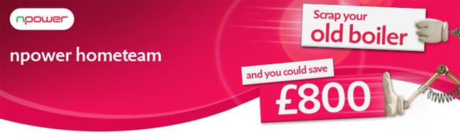

Released on: January 08, 2010, 8:16 am
Author: npower
Industry: Environment
npower has welcomed the start of the Government's home boiler scrappage scheme, and has pledged to continue its own, potentially doubling the savings offered to customers who choose to replace their boiler.
In December 2009 npower became the first energy supplier to launch its own boiler scrappage scheme.
The combination of the two scrappage schemes means consumers could be eligible to receive as much as £800 towards the cost of a new boiler, when replacing one that is over 10 years old (G rated).
Kevin Miles, CEO of npower retail, said: "It's vital we play our part in supporting this Government initiative. Customers can now enjoy £800 off the cost of a new boiler as well as saving nearly£235 off an annual gas bill, compared to a G Rated boiler*. We are delighted to welcome some of our competitors who have followed npower's example and pledged to match the Government’s scheme."
As well as its boiler scrappage scheme, npower hometeam npower hometeam installs, services and repairs boilers, in addition to offering a wide variety of heating cover options. npower hometeam provides a thorough, 30 point gas boiler service and safety check. hometeam also offers boiler repair with a choice of two ways to pay: fixed price repair, which ensures no extra charge for call out, parts or labour, and also comprises a no fix, no fee guarantee, and pay as you go repair, which covers call out and the first half hour of labour, with all work guaranteed for 12 months. npower hometeam is also offering a variety of heating cover options in conjunction with homeserve, including gas central heating breakdown cover, gas boiler breakdown cover, electrical heating breakdown cover, landlord’s gas central heating cover, home emergency cover, electrical emergency and breakdown cover, and gas supply pipe cover.
For further information on npower’s £400 offer customers can visit homeboilerscrappage.com or call 0800 0722 999. For more details on the Energy Saving Trust £400 voucher please call 0800 512 012.
Notes to editors:
* Source: Energy Savings Trust
About npower:
npower has 6.6 million residential gas and electricity accounts throughout the UK. Consumers can join the energy industry discussion on npower's interactive debating website - the brighter energy debate, where they can post their questions, views and comments.
For media information please contact the npower press office:
Nick McHugh
Press and Public Relations
npower
Oak House
Bridgwater Road
Worcester
WR4 9FP
Tel: 0845 070 2807
www.npower.com
~~~~~

Press release distributed via EPR Network (http://express-press-release.net/submit-press-release.php)

