New Free Parental Control Software Offered from Zamzom.com
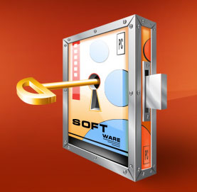

Released on: March 13, 2009, 6:29 am
Author: Zamzom
Industry: Software
Zamzom Control is freeware that offers email alerts, blocks websites, screens copy and logs web history. Zamzom’s parental control software is free and does not require registration. The software is also free of adware.
Duken, Norway (PRWEB) March 13, 2009 – Zamzom.com,http://www.zamzom.com, is proud to announce its new free parental control software. The software is easy to use and allows parents the ability to block questionable websites and monitor their kids’ time online. The software also helps keep kids safe from cyberbullies.
“Kids today have created an interactive world apart from adult knowledge and supervision. Because bullies tend to harass their victims away from the adults, the Internet is the perfect tool for reaching their victims. Zamzom is an ideal way to protect your children from becoming these bullies’ next victims,” says Per Hansen of Zamzom.com.
Zamzom control is an all-in-one solution. The program gives parents the opportunity to:
- Take a screen-shot of the desktop at specific time intervals
- Alert parents by email when the computer starts up
- Inform parents which programs have been used with specific dates and times
- Inform parents which websites have been visited with specific dates and times
- Block websites or ip addresses
Zamzom Control has a very user-friendly interface and does not require any specific computer knowledge. It is visible in the system tray and is password protected. Zamzom recommends that parents explain to their children and other computer users why they have installed the software and let them know how it works. For more information, please visit http://www.zamzom.com.
Contact:
Per Hansen
Zamzom
479-086-9958
per@zamzom.com
http://www.zamzom.com

