AmericanBridal.com Launches Social Media Platforms

Released on: April 30, 2009, 5:22 am
Author: AmericanBridal.com
Industry: Retail
The Internet’s most popular wedding favor store hosts theme-based communities on dearshirley.com and new AmericanBridal.com Facebook group
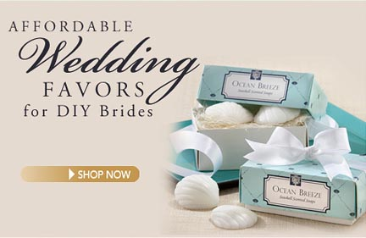
Burlingame, Calif., April 29, 2008, -- www.AmericanBridal.com, the Internet’s most expansive collection of unique and affordable wedding favors, today announced the launch of its Internet community, dearshirley.com. The site is a meeting place for those interested in wedding planning tips, advice on family and parenting and other interests. As a community, dearshirley.com provides a forum where members can join and share personal stories, tips and new finds with like-minded networks. In addition, the company has launched its Facebook group to keep members informed about its upcoming promotions and discounts.
“AmericanBridal.com is more than an ecommerce business, we have become a trusted resource for wedding planners and DIY brides,” said Shirley Tan, founder, AmericanBridal.com. “All my life, friends and acquaintances have come to me for advice, providing the inspiration for dearshirley.com, along with my love of reading the Dear Abby column. The dearshirley.com blog is a place where I can share resources and allow others to share their expertise as well.”
The launch of AmericanBridal.com Facebook group enables the company a social networking platform in which its members can join and stay abreast of upcoming promotions, discounts and other events. As a customer service-oriented company, AmericanBridal.com facilitates communication with customers via telephone, email and now, through a blog and Facebook.
A popular destination for wedding favors, bridal shower favors and discount wedding favors that don’t look like cheap wedding favors , AmericanBridal.comis now serving and shipping to U.S. and international customers.
AmericanBridal.com offers the most extensive collection of wedding favors and accessories such as party favors, wedding invitations, personalized gifts, wedding ideas, wedding flowers, cake toppers, thank you cards, wedding guest favors, shower favors, wedding jewelry, wedding decorations, wedding centerpieces, bridal shower games, wedding programs, bridal jewelry, bridal shower invitations, place cards, usher gifts, wedding albums, wedding announcements, favor boxes, unity candle, wedding anniversary gift, wedding checklist, wedding bells, wedding napkins, wedding veils and much more.
About AmericanBridal.com
AmericanBridal.com is the online source for unique and affordable wedding favors and accessories.For every theme or season, AmericanBridal.com has the most extensive selection of products that are guaranteed to make any wedding an unforgettable event for the bride and groom and their guests. From fun and unusual to traditional and elegant, Americanbridal.com specializes in personalized wedding favors, attendant gifts, wedding ceremony accessories, unique bridesmaids gifts and groomsmen gifts, bridal accessories and jewelry, and themed wedding favors. AmericanBridal.com offers the selection of a showroom with the convenience of online shopping and superior customer service at prices that can’t be beat. For more information, please visit us at www.AmericanBridal.com.
# # #
Contact Details: Shirley Tan
AmericanBridal.com
Shirley@americanbridal.com
800-568-3398

