Wyevale website launches the Gardening Club


Released on: April 24, 2009, 6:36 am
Author: Wyevale
Industry: Retail
Wyevale Garden Centres has overhauled its website to allow users easy access to the gardening club features as well as providing each garden centre with its own personal web page.
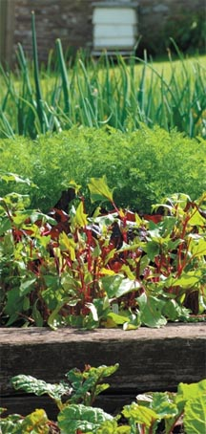
The extra prominence afforded to the gardening club means that shoppers can sign up to the club for free and then add details of their gardening club card, in order to get points with in-store purchases as well as by buying online, whether they're getting a Flymo lawnmower, a new log store or just a new plant pot.
Every £1 spent by a gardening club member will result in five club points for the shopper who can then track their points total online thanks to a new online tool. Points are later redeemable as vouchers. Registered members will also receive an exclusive e-mail newsletter and will be privy to offers online that are otherwise not visible to visitors who are not part of the gardening club.
The website header of the main site has been rebranded to become Gardening Club so that each garden centre in the family can rediscover its own brand identity, allowing individualism and personality to come out on their personal web page.
An online store finder is available to help website visitors find their nearest garden centre, where they can then find out opening times and other pieces of relevant information. Each garden centre web page targets customers directly by giving them information about facilities available, their address and other contact details. A personal touch is added to each garden centre page with the name and an image of the manager published alongside a topical gardening tip.
The website now supports both the garden centres' and The Gardening Club's e-commerce services to supply every gardening need from plants to care products, tools to garden furniture and sheds to bird houses. Other features on the Gardening Club website include monthly gardening advice topics and the option to hire tools and machinery.
About The Gardening Club
The Gardening Club is a family of garden centres. The group stocks a wide range plants, tools, garden furniture, BBQs and machinery to suit every style of gardening. With over 120 garden centres nationwide and a website stocking over 2,000 gardening products there is something for every gardeners taste.
For more information, please contact:
Rachel Burks
Porcupine PR
Fairway
Bristol Road
Bridgwater
Somerset
TA6 4AW
United Kingdom
01278 446801
www.wyevale.co.uk

