BabyBox.com Presents Newport Cottages Baby Furniture


Released on: May 25, 2009, 7:49 am
Author: Babybox.com
Industry: Retail
Luxury baby retailer continues the tradition of fine, heirloom quality furniture with the addition of new collections
(Darien, Conn.) May 20, 2009 -- www.BabyBox.com, a luxury retailer of high-end crib bedding, baby furniture and baby gifts, today announced it has added a line of nursery and children’s bedroom furniture from Newport Cottages. Newport Cottages quality craftsmanship is found throughout their bench-made hardwood furniture, offering a variety of styles and finishes from which to choose.
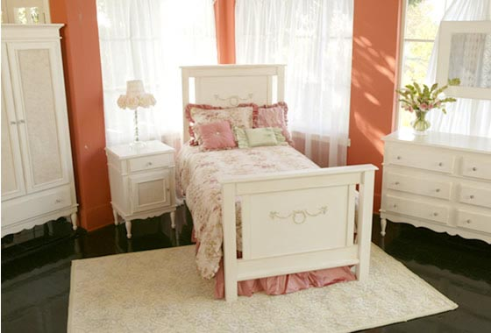
“Early in life, a nursery is where your baby spends a lot of time and as they mature, the child’s room becomes a key part of their growing independence,” said Katherine Type, founder of BabyBox.com. “Creating your child’s retreat from the world begins with heirloom quality bedroom furniture that will last for generations. Newport Cottages exceeds our high standards, offering a range of styles to fit any décor or theme — its addition complements our fine selection of high-end baby furniture.”
The Newport Cottages custom painted cribs range from the simple lines of the Ricki crib to the soaring posts adorning the Madison crib. Newport Cottages beds are known equally for craftsmanship as well as whimsical styling. Each is available in 19 different hues to match any mood and room design. Changing tables, dressers and armoires feature feminine or masculine lines to complement the crib or bedroom furniture.
Celebrity moms and dads that favor Newport Cottages for their newborns include Halle Barry, Tori Spelling, Minnie Driver and Mr. and Mrs. Kelsey Grammer. Minnie Driver chose the Celine crib, dresser, nightstand and armoire while the Grammer couple opted for the feminine styling of the Tiffany collection, which features a delightful upholstered crib. The Spellings welcomed baby Stella Doreen to her nursery, whose focal point is the Newport Cottages Cape Cod crib adorned with rose appliqués.
The producers of “Army Wives” contacted Newport Cottages to furnish the ideal nursery for show star Lieutenant Colonel Joan Burton. Their search for heirloom pieces reminiscent of South Carolina history came to a conclusion when they selected the Cottage Crib with posts, the Samantha Changer with Roses, the Storytime Bookstand and the Newport Cottages Classic Highchair.
From developmental toys to baby clothing, crib bedding and nursery furniture, BabyBox.com features an A-list of upscale designers, such as House Inc., Henry & Henrietta, Lulu DK Matouk, Lulla Smith, Gordonsbury, Serena & Lily, Blauen, Sweet William, Lullaby and Baby B, among others.
About BabyBox.com
BabyBox.com is a premier baby gift store for children, ages newborn to 12 months. Offering a specialized selection of luxury baby items, the company prides itself on serving a niche market with a focus on unique and high quality products including adorable baby clothes, crib bedding, nursery décor, quality children's furnishings, baby furniture, custom baby bedding, Moses baskets, bassinets, handmade items, as well as traditional gifts, such as toys, baby blankets and keepsake gifts. In addition to the specialized infant collections, BabyBox.com has expanded its offerings to provide furniture, bedding, décor and clothing for older children. With headquarters in Darien, Conn., BabyBox.com has provided unique baby gifts since 1997. For more information, please visit www.BabyBox.com.
# # #
Contact Details: Katherine Type
Founder/President
(203) 655-0185

