MyWeddingFavors.com Blog Spotlights

Released on: May 4, 2009, 3:10 am
Author: Susan Hawkins
Industry: Retail
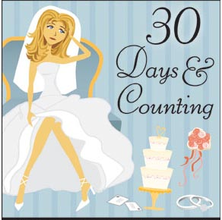
The blog for MyWeddingFavors.com, the nation’s premier online retailer of wedding favors, baby shower favors and wedding accessories, announces a new series of interviews with brides-to-be who are 30 days away from walking down the aisle. Called 30 Days and Counting: Brides on the Brink, the blog posts will get inside the minds of these women to reveal the highs and lows of wedding planning for up-and-coming brides who are preparing for their journey down the aisle.
Brides on the Brink will talk about the most important things on their mind, how they are handling stress, the most difficult part of wedding planning, the most rewarding part of wedding planning, what they would have done differently, any last-minute details they’re encountering, life lessons learned and more.
My Wedding Favors blogger Karen Sullen says, “We’re stoked about this new series, because the first two brides on the brink are right here at My Wedding Favors. Our goal is to provide first-hand information that will help future brides look forward to the planning process, avoid some pitfalls and side-step stress as they plan their weddings.”
The series will appear in www.blog.myweddingfavors.com the first and third week of every month. Brides-to-be who are about 30 days from their wedding date are invited to send their contact information to shawkins@theshopsat24seven.com. Featured brides will receive a $25 gift certificate for My Wedding Favors.
Contact Details: Media Contact: Susan Hawkins
Senior Copywriter
Blog.MyWeddingFavors.com
678-282-0053 ext. 714
shawkins@theshopsat24seven.com

